1.7 Answer to check your

progress questions

1. Surplus of BOP

2. Current A/c, CapitalA/C, and

Official reserve a/c.

3. Assets and liabilitires

4. Trading

5. Swap deal

6. Currency Market

7. Nostro

8. Vostro

9. Forward contract

1.8 Model Questions

1. What is BOP? State its

importance and limitations.

2. Bring out the link between

current account and capital

account.

3. Discuss briefly about the FOREX

market.

4. Discuss the theories of foreign

exchange.

5. Listdown the major sources of

foreign exchange.

6. Examine the various theories of

Exchange rate.

7. Write a short notes on the

following

a. Vostro

b. Nostro

c. Bid-Ask rate

d. Forward transaction

e. Arbitrage

f. Purchasing Power and

Interest rate Parity

g. The Fisher

**1.3.1 BALANCE OF PAYMENT**

* It is systematic accounting that keeps the record of all the monetary transaction between a country and its citizens and the other countries and their citizens over a fixed period of time.
* Includes of - Inflow and outflow of capital | Export and import of goods and services.
* Summarized record of international transaction.
* Transaction made both public, private entity with foreign countries.
* Trends of cash glow, flown out and entered the country.
* It held in formulation and implementation of monetary policy and fiscal policy.
* Export on credit side and import on debit side.
* BOP records commercial, financial and economic flow between the resident of a given country .
* Measures flow than stock
* Resident of country means – individual, business, organization, government agency or any other institution. not only citizens.
* Ex: - Private capital flow and official reserves.
* Sources – credits and Uses (debit)
* Net surplus or deficit during the referred period.
* France and Germany had prepared the accounts of their export and import known as Balance of Trade.
* **the major source of funds for country accrue from.
  + Export of goods and services
  + Sales of existing foreign financial assets.
  + Foreign loans/borrowing , etc.,

Likewise, the major uses are

* + Import of goods and services
  + Purchase of foreign financial assets.
  + Foreign lending and so on..,

**PRESENTATION OF BALANCE OF PAYMENT:**

BOP statement is divided into several accounts:

1. Current account.
2. Capital account.
3. Official reserve account.
   1. Import &Exp data (customs authorities)
   2. Changes in foreign assert and liabilities by financial institution.
   3. Additional account in BOP - Error and Omission.

Brief description of various accounts in the BOP statement.

1. Visible Exp and Imp
2. The Current Account is a record of the trade in goods and services.
3. The trade in goods is composed of export( selling Merchandize (goods) to foreigners) and import (buying Merchandize (goods) from abroad)….Real asserts
4. Invisible Exp and Imp
   1. The trade in services (also called invisibles ) includes interest, dividends, travel expenses and financial charges , etc ----Pending
   2. the country's shops and hotels provide to foreigners shipping sectors render
   3. Unilateral transfers consist of remittances by migrants to their kith and kin, and gifts. Donations and subsidies received from abroad.
   4. The Capital Account is divided into foreign direct into foreign direct

investment (FDI), portfolio investment and private short-term capital flows.

1.3.2. Current Accounts

**Goods Account**

Exports (+) | Imports (-)

Balance of Goods Account=A (I)

**Services Account**

Receipts as interest and dividends, tourism receipts for travel and financial changes (+) Payments as interest and dividends, tourism payments for travel and financial charges (-) Balance of Services Account (II)

**Unilateral Transfers**

Gifts, donations, subsidies received from foreigners (+) Gifts, donations, subsidies made to foreigners (-) Balance of Unilateral Transfer Account= A (III)

**Current Account Balance: A(I)+A(II)+A(III)**

B. **Long-term Capital Account**

**Foreign Direct Investment (FDI)**

Direct investment by foreigners (+) & Direct investment abroad (-)

Balance on Direct Foreign Investment=B (I)

**Portfolio Investment**

Foreigner's investment in the securities of the country (+)

Investment in securities abroad (-)

Balance on Portfolio Investment=B (II)

**Balance on Long-term Capital Account=B (I) +B (II)**

**Private Short-term Capital Flows**

Foreigner's claim on the country (+) Short-term claim on foreigners (I) Balance on Short-term Private Capital Account=B (III)

**Overall Balance: [A(I)+A(II)+A(III)+[B(I)+B(II)+B(III)]**

C. **Official Reserves Account**

Decrease or increase in foreign exchange reserves.

These reserves are composed of **gold, convertible currencies like US Dollar, Deutsch Mark, Japanese Yen, SDR (Special Drawing Rights), etc.**

since BOP is expressed in national currency, an increase in any of these assets means a use of funds while their decrease implies a source of funds.

If overall balance (current plus capital) is in deficit, this implies either a reduction in reserves or an increase in foreign debt or reduction of credits.

Pending --------

**Importance of BOP**

This permits a judgment on the economic and financial situation of

a country in the short-term. If a country has significant deficit, it will

have a tendency to take stiff measures for diminishing its imports.

**Limitations of BOP Statement**

Sources of information used to prepare a BOP Statement are varied, namely, central bank, institutions linked with external trade such as Export-Import (EXIM) Bank, and customs authorities, etc. A perfect coherence among these sources may not be possible. Thus, the account Errors and Omission serves to bring about equilibrium between economic operation and their monetary counterparts.

BOP is expressed in national currency. But often the operations have been done in other currencies. This causes the problem of exchange gain or loss, which is ignored.

**ADJUSTMENT OF DEMAND AND SUPPLY OF FOREIGN CURRENCY**

Central bank intervenes through its regulatory stocks. This exercise is necessitated to control the volatility of exchange rate as and when it anticipates a surplus over demand (surplus of the BOP) or vice versa. For example,

For example, if a deficit is anticipated, the central bank will

offer foreign currency that is holds in reserve. In 1995, RBI sold huge

amount of dollars to decrease the significant increase in dollar value.

**The link between the national economy and international activities.**

This section provides a framework consisting of a set of basic macroeconomic accounting identities that link domestic production and spending to saving, consumption and investment behavior and their relationship with current account and capital account balances

1.3.3 Domestic Savings, Investment and the Capital Account

The national income (or product) is the sum of consumption and savings, that is:

**National Income = Consumption + Saving (2.1)**

Similarly, national spending consists of consumption and investment:

**National Spending = Consumption + Investment (2.2)**

From Eqs (2.2) and (2.2), we obtain:

National Income – National Spending = Saving – Investment (2.3)

**Link between the Current and Capital Accounts**

National Income – National Spending = Exports – Imports (2.4)

By combining Eqs.(2.3) and (2.4), we get:

Saving – Investment = Export – Imports ----------- (2.5)

Net foreign investment = Export – Imports (Capital outflow) -------(2.6)

**Government Budget Deficit and Current Account Deficits**

**Current account balance = Saving Surplus – Govt. Budget Deficit ----------2.9**

Equation 2.9 reveals that nation's current account balance is identically equal to its private savings investment balance less the government budget deficit. That is, a nation running a current account deficit is not saving enough to finances its private investment and government budget deficit. Conversely, a nation running a current account surplus is saving more than is needed to finance its private investment and government deficit.

**Balance of indebtedness**

Based on the circumstances, the customer may end up in any of the following ways:

1. Delivery on the due date. (the rate applied for the transaction would be the rate originally agreed, irrespective of the spot rate prevailing.)

2. Early delivery. (When a customer requests early delivery of a forward contract)

3. Late delivery.

**4.** Cancellation on the due date.

5. Early cancellation.

6. Late cancellation.

7. Extension on the due date.

8. Early extension.

9. Late extension

**Delivery on Due Date:**

**Early Delivery:**

**Cancellation/Extension of forward contract:**

The customer is having the right to cancel a forward contract at any time during the currency of the contract. The cancellation is governed by Rule 8 of the FEDAI.

The difference between the contracted rate and the rate at which the cancellation is done shall be recovered or paid to the customer, if the cancellation is at the request of the customer.

**Cancellation of Forward Contract on Due date:**

* When a forward purchase contract is cancelled on the due date it is taken

that the bank purchases at the rate originally agreed and sells the same

back to the customer at the ready TT rate. The difference between these

two rates is recovered from/paid to the customer.

* If it is lower, the difference is recoverable from the customer.

**Early Cancellation of a Forward Contract:**

When such requests come from the customer, it

would be cancelled at the forward selling rate prevailing on the date of

cancellation, the due date of this sale contract to synchronize with the due

date of the original forward purchase contract. On the other hand if a

forward sale contract is cancelled earlier than the due date, cancellation would be don

**Extension on Due date:**

An exporter finds that he is not able to export on the due date but expects to do so in about two months. An importer is unable to pay on the due date but is confident of making payment a month later. In both these cases they may approach their bank with whom they have entered into forward contracts to postpone the due date of the contract. Such postponement of the date of delivery under a forward contract is known as the extension of forward contract. The earlier practice was to extend the contract at the original rate quoted to the customer

Further only a flat charge of Rs.100 (minimum) should be recovered and not Rs.250 as in the case of booking a new contract.

**Overdue Forward Contracts:**

As we have already seen, the customer has the right to utilize or cancel or extend the forward contract on or before its due date. No such right exists after the expiry of the contract.

FEDAI Rule 8 provides that a forward contract which remains overdue with any instructions from the customer concerned on or before its due date shall on the 15th day from the date of maturity be automatically cancelled by the bank.

The customer remains liable for the exchange difference arising there from but if it results in profit it need not be passed on to the customer. In case of delivery subsequent to automatic cancellation the appropriate current rate prevailing on such delivery shall be applied

**Roll over Forward Contracts:**

When deferred payment transactions of imports/exports takes place, the repayment of the installment and interests on foreign currency loans by the customer requires long term forward cover where the period extends beyond six months.

The bank may enter into forward contract for long terms provided there is suitable cover is available in the market. However the cover is made available on roll over basis in which cases the initial contract may be made for a ***period of six months*** and subsequently each deferred installments for the outstanding balance of forward contract by extending for further periods of six Roll over Forward Contracts: months each. For these transactions the rules and charges for cancellation / extension of long term forward contracts are similar to those of other forward contracts.

**TRADING**

Trading refers to purchase and sale of foreign exchange in the market other than to cover bank‘s transactions with the customers.

**Swap Deals**

A ‘swap deal’ is a transaction in which the bank buys and sells the specified foreign currency simultaneously for different maturities. Thus a swap deal may involve:

• Simultaneously purchase of spot and sage(wise) of forward or vice versa; or

• Simultaneously purchase and sale, both forward but for different maturities, For

There should be simultaneous buying and selling of the same foreign currency of same value for different maturities; and

• The deal should have been concluded with the distinct understanding between the banks that it is a swap deal.

A swap deal is done in the market at a difference from the ordinary deals. In the ordinary deals, the following factors enter into the rates;

• The difference between the buying and selling rates; and

• The forward margin. i.e., the premium or discount.

In a swap deal, the first factor is ignored and both buying and selling are done at the snow rate.

1.3.4 Foreign exchange market

IT is a global decentralized market for the trading of currencies. The main participants in this market are the larger international banks.

• its huge trading volume representing the largest asset class in the world leading to high liquidity;

• its geographical dispersion;

• its continuous operation: 24 hours a day except weekends, i.e., trading from 20:15 GMT on Sunday until 22:00 GMT Friday;

• the variety of factors that affect exchange rates;

• the low margins of relative profit compared with other markets of fixed income; and

• the use of leverage to enhance profit and loss margins and with respect to account size.

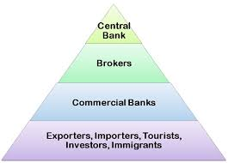

**Spot exchange rates**

The spot exchange rate is the rate existing in the market at any given moment. It can be considered as the rate of exchange for immediate delivery of the currency. The spot rate will change all the time according to the changes in supply and demand in the market.

**Forward exchange rates**

The forward exchange rate is a rate for a given time in the future. A price is agreed now for an exchange at some time in the future (often 3 months or so). Whatever happens to the spot rate between now and then, the contract will be met at the rate that was agreed.

This process is called ‘**hedging’ against risk.** The existence of the forward market also creates the potential for speculation. Depending on the reason for buying or selling the currency the dealer could end up better off or worse off.

**Theories of Foreign Exchange**

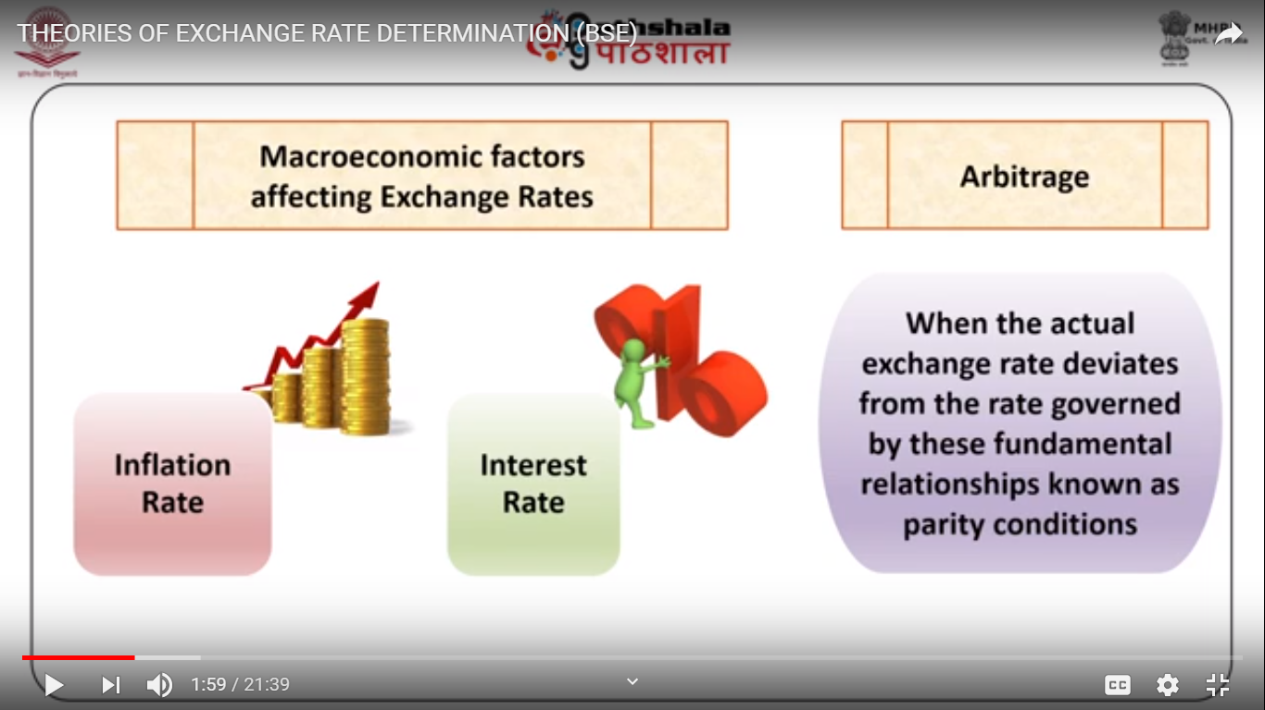

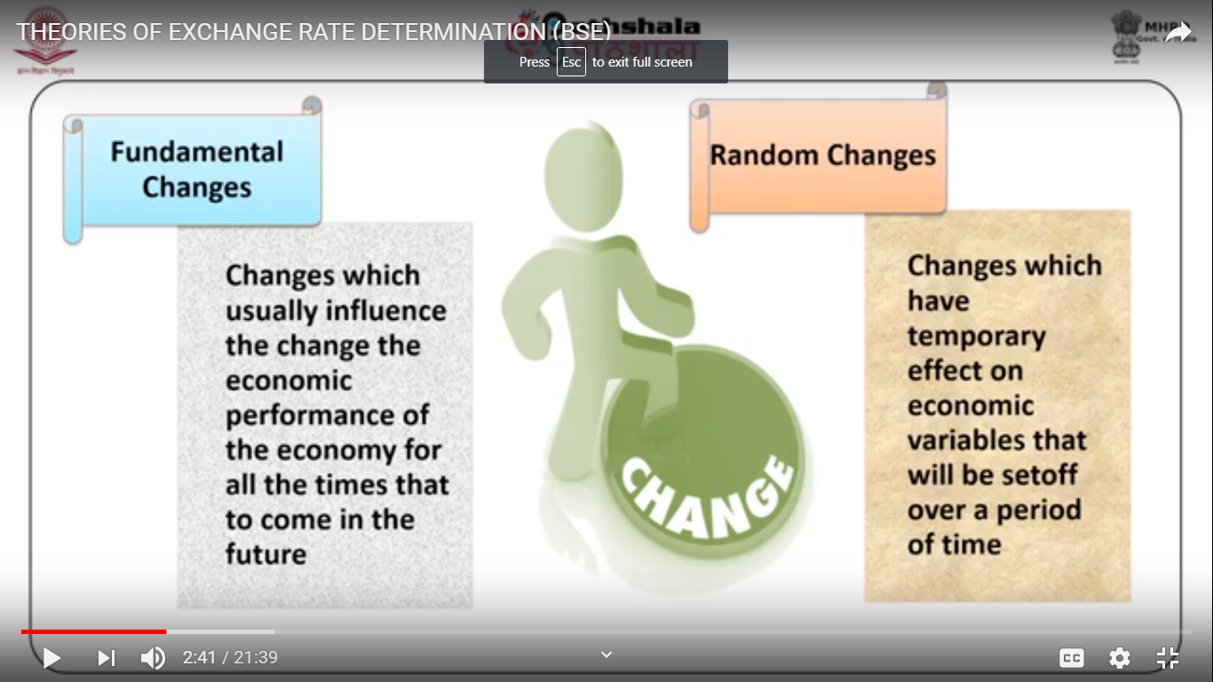

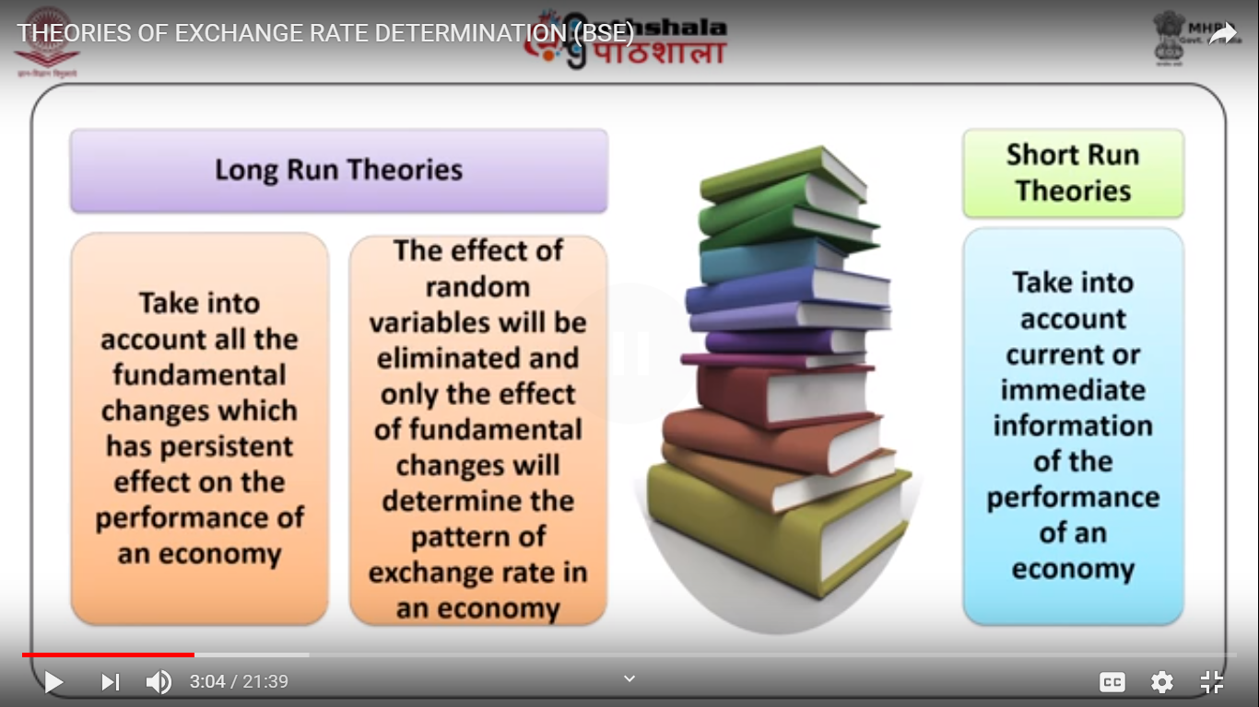

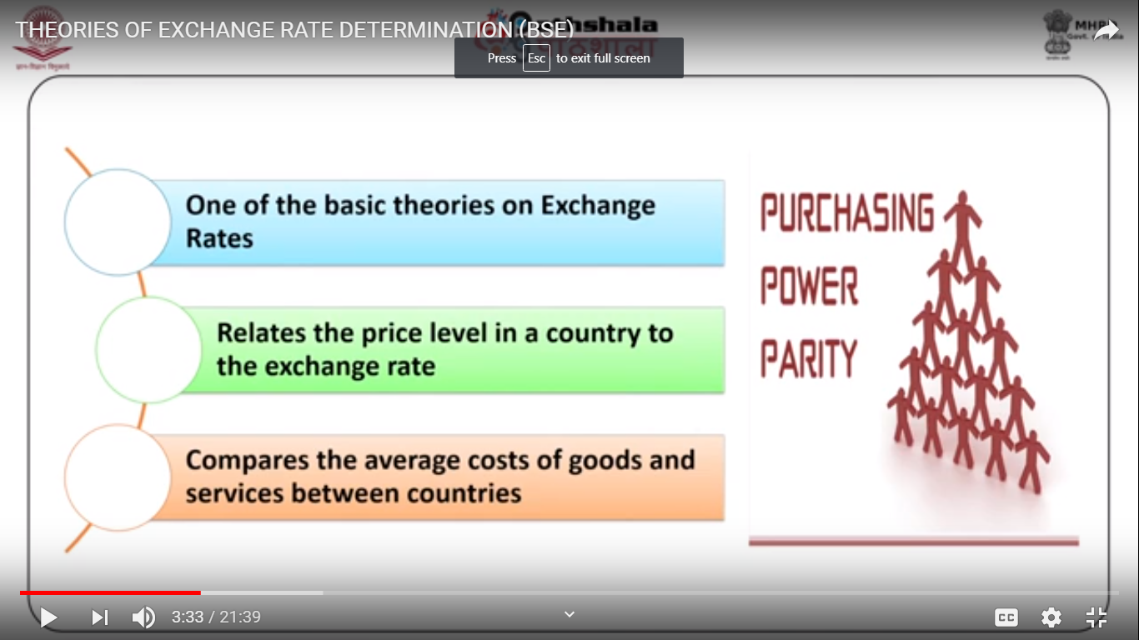

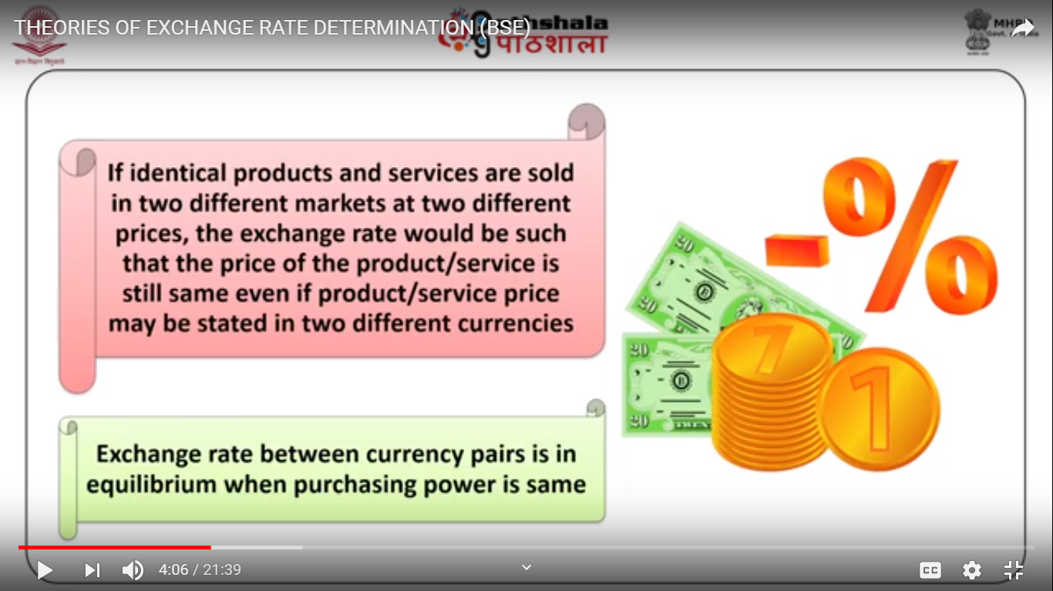

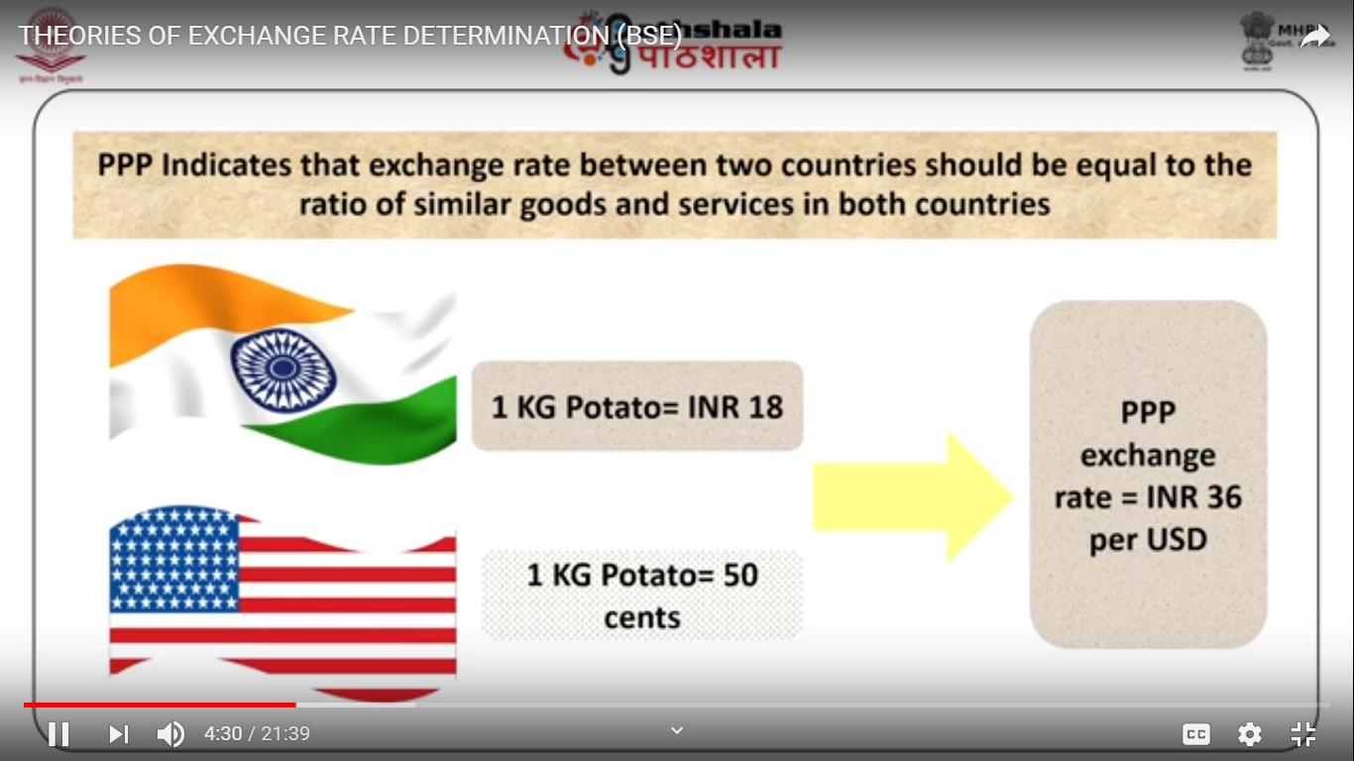

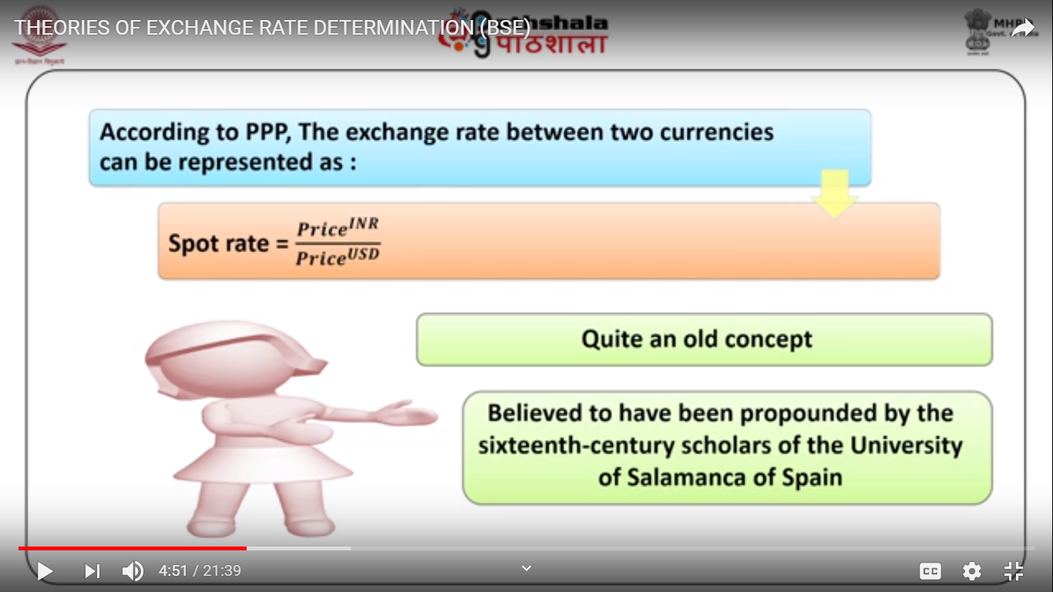

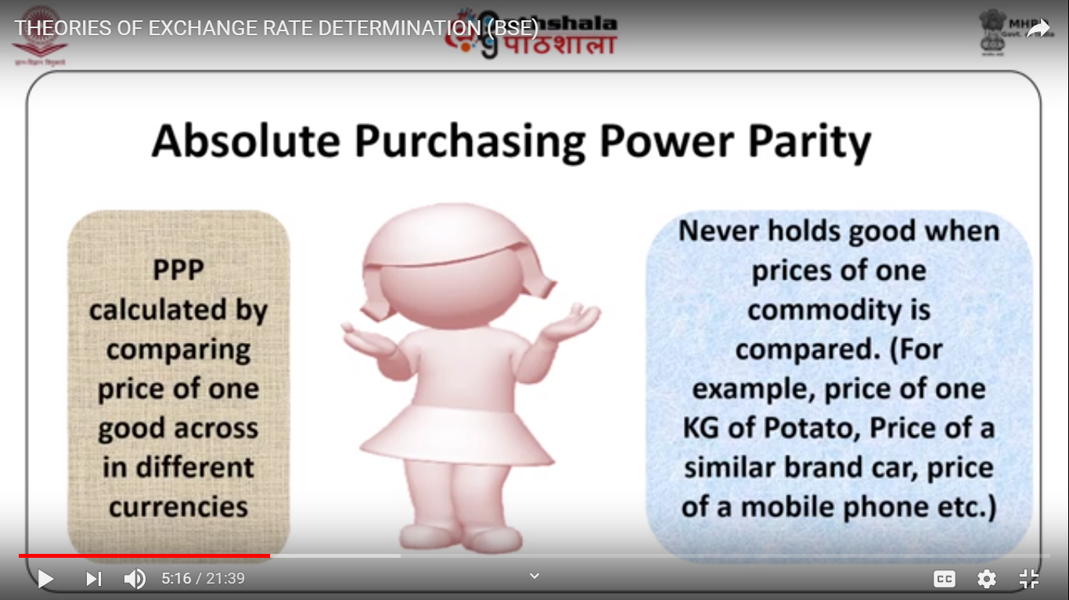

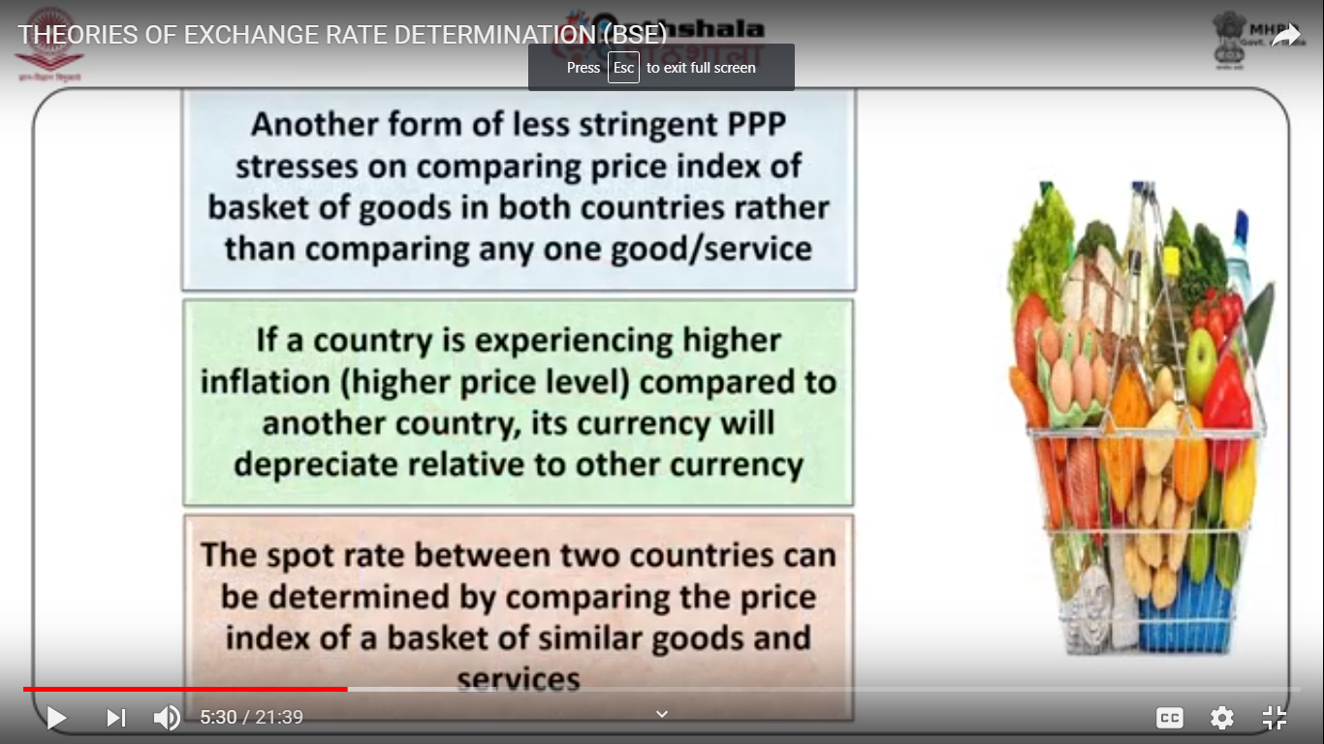

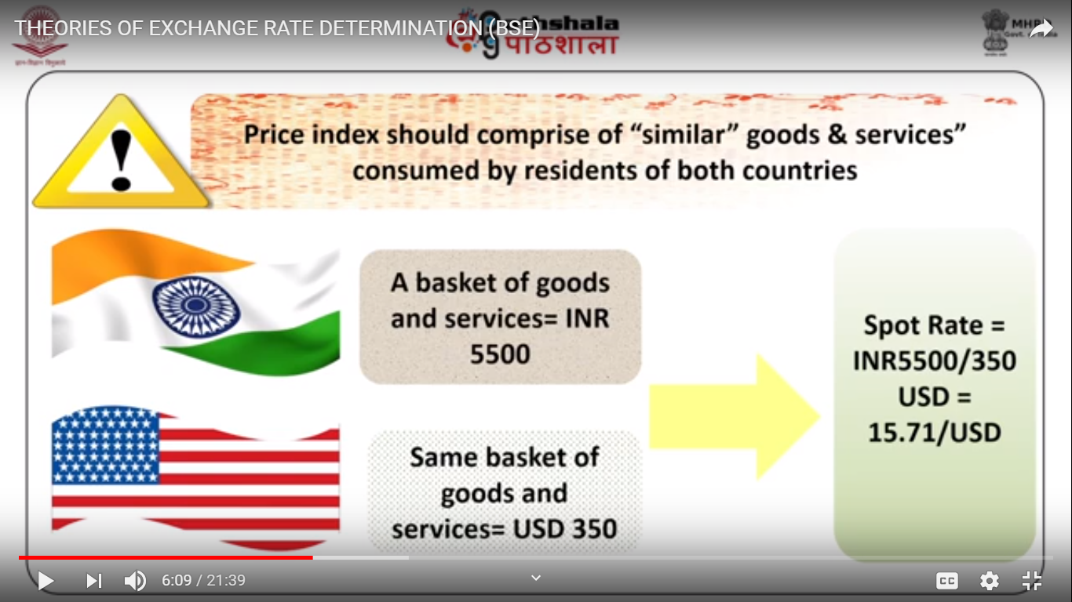

**Sources of Foreign Exchange stocks and shares image by Andrew Brown from Fotolia.com**

1. **International Trade**
2. **International Investors**
3. **Currency**

In addition to global demand for a country‘s securities and exports, a country's currency is affected by dayto- day movements in prices driven heavily by speculative trading activity, such as day trading. Unlike international trade and investment, price movements driven by speculation are less indicative of economic conditions and more indicative of the perceptions of those engaged in speculative trading. Exchange Rate - the exchange rate represents

There are two ways to express an exchange rate between two currencies (e.g. the $ and ￡ [pound]). One can either write $/￡ or ￡/$ .

**Currency Value:**

It is important to note that the value of a currency is always given in terms of another currency. Thus the value of a US dollar in terms of British pounds is the ￡/$ exchange rate. The value of the Japanese yen in terms of dollar is the $/\ exchange rate.

Currency appreciation - a currency appreciates with respect to another when its value rises in terms of the other.

Currency depreciation - a currency depreciates with respect to another when its value falls in terms of the other.

The rate of appreciation (or depreciation) is the percentage change in the value of a currency over some period of time.

**Example #1:**

On Jan. 8 1997, E\/$ = 116

On Jan. 8 1996, E\/$ = 105

Use percentage change formula:

(New value - Old value)/Old Value

(116 − 105)

105 = 105

11 = 0.105

change is negative,

**1.3.5 PARTICIPANTS IN THE FOREX**

A FOREX market refers to the activities of major international banks that engage in currency trading. banks act as intermediaries between the true buyers and sellers of currencies, ie, governments, businesses, and individuals. These banks will hold foreign currency deposits and stand ready to exchange these for domestic currency upon demand.

**Importers and Exporters**

**International Investors, Banks, Arbitrageurs etc.**

**Investment Concerns - International or Domestic**

**1. Rate of return**

Example 1:

Suppose a Picasso painting is purchased in 1996 for $500,000.

One year later the painting is resold for $600,000. The rate of

return is calculated as,

(600, 000 − 500, 000)

500, 000 x 100 = 100, 000

500, 000x 100 = 0.20x100 = 20%

**2. Risk**  **3. Liquidity**

Liquidity essentially means the speed with which assets can be converted to cash.

**Calculating Rate of Returns on International Investments**

Step 1 - Convert the dollars to £.

Step 2 - Purchase the British CD and earn interest in £s during the year.

Step 3 - Convert the principal plus interest back into dollars

in one year.

Interpretation of the Rate of Return Formula

**Purchasing Power Parity**

1.3.6NOSTRO ACCOUNT

* Account held by a particular domestic bank in a foreign bank is called Nostro account.
* if SBI India opens an account in UBS Switzerland then that account is a Nostro account for SBI India.

1.3.7 VOSTRO ACCOUNT

* Account held by a foreign bank in a domestic bank is called

________ account.

**CONVENTIONS**

A bank counts a nostro account with a debit balance as a cash asset in its balance sheet. Conversely, a vostro account with a credit balance (i.e. a deposit) is a liability, and a vostro with a debit balance (a loan) is an asset.

that is, if a nostro in credit has a positive sign, then a vostro in credit must have a negative sign. This allows for a reconciliation by summing all accounts to zero (a trial balance) - the basic premise of double-entry bookkeeping.

**TYPICAL USAGE**

Nostro accounts are mostly commonly used for currency settlement, where a bank or other financial institution needs to hold balances in a currency other than its home accounting unit.

1.3.8 Bid-Ask rates

A bid price is the highest price that a buyer (i.e., bidder) is willing to pay for a good. It is usually referred to simply as the “bid.”

ASK PRICE

Ask price, also called offer price, offer, asking price, or simply ask, is the price a seller states she or he will accept for a good.

A Bid is made up of a Buy Limit Order that has been put into the market. An Ask is made up of an open Sell Limit Order.

The difference between the bid price and the ask price is called the spread.

For example, if the bid price is $20 and the ask price is $21 then the "bid-ask spread" is $1.

for example the price of IBM might be quoted as 110 - 112. This means that if you want to day trade IBM and want to BUY a single share, it will cost you 112 dollars, but if you want to SELL a share, you will only get 110 dollars for it. In the morning papers,

**ECN**

ECN (standing for “electronic communications networks”) are automated order matching systems.

If a day trading request to buy or sell a stock or security is sent to any ECN, the ECN attempts to match the order to an opposite order (i.e a sell if its a buy, or a buy if its a sell) of the same size.

**Spot Transactions and Forward Transactions:**

* When the payment in rupees and receipt in US $ takes place after some time (due to time involved in administration of the transaction), say two days later, it is called a spot transaction.
* When the payment in rupees and receipt in US $ takes place on some predetermined future day, it is called a forward transaction.

**Major Buying and Selling Rates**

Depending upon the time taken in realization of foreign exchange purchased by the bank .

(a) instantaneously, in case of purchase of drafts issued by correspondent bank, which must have credited nostroaccount at the time of issue of the draft or

(b) with delay of some time, in case of purchase of foreign bill, which will be collected by the foreign correspondent and then the proceeds credited to nostroaccount),

the two as of buying rates are quoted by banks in India which are called TT buying rate and Bill Buying Rate.

Similarly for sale transactions also, TT selling rate and bill selling rates are quoted.

**TT Buying Rate:**

When no delay is involved in realisation of the foreign exchange by the bank or Nostro account is already credited, TT Buying rate is applied which is calculated after deducting the exchange margin from the interbank buying rate, determined by the bank.

The rate is generally applied for payment of demand drafts, mail transfers, foreign bill collected or cancellation of foreign exchange already sold earlier.

**Bills Buying Rate:** When some delay in realisation of foreign exchange by the bank is involved, say in case of purchase of bill drawn on a customer in London, when nostro account is credited after collection of the bill by the correspondent bank in London, bill buying rate is applied.

Such rates are calculated by adding the forward premium for transit and usance period, rounded off to lower month (or reducing the forward discount rounded off to the higher month) and reducing the exchange margin from the spot buying rate.

**TT Selling Rate:** When handling of documents by the bank is not involved (say, in case of demand drafts, mail transfers, etc, or there is cancellation of foreign exchange purchased earlier), TT selling rate is to be applied which is calculated on the basis of inter bank selling rate by adding exchange margin.

**Bills Selling Rate:**

When transactions involve handling of documents, such as payment for import documents, bills selling rate is applied, which is calculated by adding exchange margin to the TT selling rate.

1.3.9 FORWARD TRANSACTIONS

These contracts, a banker and customer enter into an agreement to buy or sell a fixed amount of foreign currency on a future specified date at a pre-determined rate of exchange.

Exporter, for instance, sells foreign exchange of specified amount and currency at a specified future date which assures him definite payment and the banker agrees to buy the same amount and currency at a predetermined rate, which assures him definite availability of foreign exchange.

A forward contract, where the delivery of forex should take place on a specified future date is known as Fixed Forward Contract.

On the other hand, where the customer can sell or buy forex from the bank, on any day during a given period of time (say between January 05 to January 15), at a predetermined rate, is called Option Forward Contract.

**1.3.5 Arbitrage**

Arbitrage, generally means buying a product when its price is low and then reselling it after its price rises in order to make a profit.

Currency arbitrage means buying a currency….

**Spot Exchange Rate**

The spot exchange rate refers to the exchange rate that prevails on the spot, that is, for trades to take place immediately.

**Forward Exchange Rate**

The forward exchange rate refers to the rate which appears on a contract to exchange currencies either 30, 60, 90 or 180 days in the future. Forward contracts can be used to reduce exchange rate risk.

Importer could protect himself against this potential loss is to purchase a forward contract to buy € for $ in 60 days.

**Hedging** - a currency trader is hedging if he or she enters into a forward contract to protect oneself from a downside loss. However by hedging the trader also losses the potential for an upside gain.

Thus, hedging protects against loss but at the same time eliminaters potential unexpected gain.

**BOP Theory of Exchange Rate**

The BOP theory of Exchange Rate is a statistical record of all the monetary transaction or payments that takes place between the inhabitants of one country and the rest of the world over a specific time period.

According to this theory the demand and supply of a currency depends on the flow of money related to the Balance Of Payments.

Balance of payments can be achieved through trades in goods and services, direct investment and portfolio investments.

A BOP is the term used to denote the cash balance of a country and does not refer to the balance sheet.

Precisely the BOP must be ‘zero’ denoting that equal amount of inflow and outflow has taken place.

**Divisions in BOP**

The Capital and Financial Account

• The Current Account

• The Official Reserve Account

The Capital and Financial Account

Ideally the BOP has to be zero and to maintain this there is another item called Statistical Discrepancy (SD). The SD reflects bad transactions that have been omitted

1.3.11 Exchange Rate Theories

The effective exchange rate is also called the ‘sterling index' or perhaps the 'sterling trade-weighted index’. It is an exchange rate calculated from a basket of currencies, and can perhaps best be thought of as an average exchange rate.

This is the supply and demand of pounds traded on the foreign exchange market and is NOT the amount of sterling in circulation! A high level of demand for a currency will force up its price - the exchange rate. Where supply is equal to demand is the equilibrium exchange rate, as shown in the diagram below.

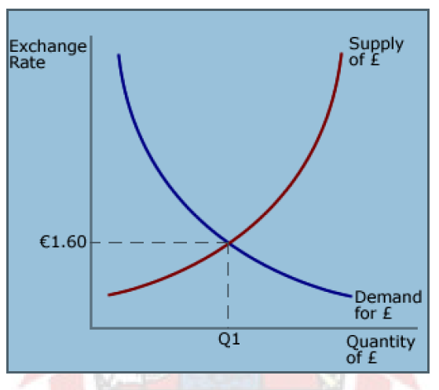

The demand for £ comes from people who are investing in the UK from abroad and so need pounds, or from firms who are buying UK exports. They will need pounds to be able to pay for the goods. The supply comes from people in the UK who are selling pounds. This

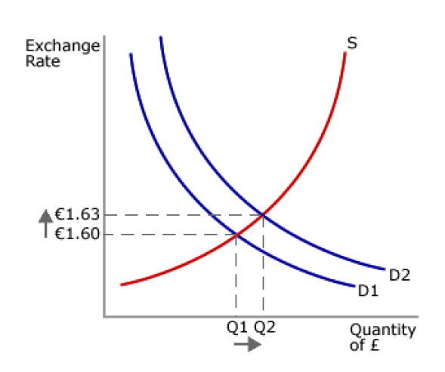

**BALANCE OF PAYMENTS (BOP) AND EXCHANGE RATES**

A Balance of Payments, which is also referred to as BOP, is a type of accounting record whereby all of a **country's monetary transactions** associated with the rest of the world are recorded.

The types of transactions included on the BOP **sheet include export and import payments** for goods, services, capital, and even financial transfers.

In other words, the Balance of Payments sheet is used **to summarize all international transactions that take place within a designated amount of time**, which is typically 12 months.

Keep track of investments and loans, as well as exports, which are listed as surplus.

Might be as investment **in one or more foreign countries or imports**. In this case, the entries are listed as a deficit.

the next step is **balancing the sheet**. In this case, the **sum to zero** must be determined so ultimately, no surplus or deficit would exist.

* Let us say that a particular country **was importing a greater amount of goods** than what it exports. Using this scenario, the Balance of Payments accounting record would show a deficit, which would then need to be balanced out in some way.
* This might be accomplished by **reducing reserves, earning funds from investments** in foreign countries, or perhaps receiving loans from foreign countries.
* The Balance of Payment sheet has been comprised of two divisions since

1973 to include **the current account and the capital account.**

* The sum of the **current account includes any net earnings on exports** but also any payments made on exports.
* Then for the **capital account on the BOP sheet, this is a record of net change** in ownership of foreign assets.
* In this case, the record would include the **reserve account,** which is the nation's **central bank operations internationally, plus investments and loans between one country and other countries** in the world.
* The only exclusion would be f**uture regular repayments, loan dividends, and investment yield,** which would actually be recorded on the BOP current account sheet.
* The only exclusion would be **future regular repayments, loan dividends, and investment yield,** which would actually be recorded on the BOP current accou**nt sheet.**

**Theory of Exchange Rate Determination**

Theory of Exchange Rate Determination can be explained using different approaches. In the following section we have dealt with some of them.

**Determinants of Exchange Rates**

The Purchasing Power Parity or PPP happens to be one of the most significant approaches to determine exchange rate. PPP is primarily based on the “Law of One Price”. However, this law is based on the assumption that identical goods are sold at equal prices.

It is a flow model of the balance of payment. This law lays down that exchange rate of currencies have to compensate for the differences in prices of goods. The Relative PPP approach continues to be applied till date. This approach lays down the fact the exchange rate has to compensate for the difference in inflation rate. PPP is not a very reliable determinant since changes in technology, commercial policies, labor force and tastes change the national productivity, which in turn changes the real exchange rate.

The Balance of Payment Approach depends on the assumption that there exists an exchange rate and there exists internal and external equilibrium. The internal equilibrium is based on the assumption that there is full employment. The external equilibrium is the equilibrium in the balance of payments. This theory is more dependable as it can explain permanent deviations in PPP. This approach offers guidance on short term ups and downs. There are certain disadvantages of this approach. The model does not inform about the exact rate of unemployment. Next, the exchange rate does not maintain its consistency in accordance with the external accounts.

Monetary and Portfolio Approach is an approach in which the prices of various domestic and foreign assets are decided. The agent is given a portfolio choice of various assets. The instruments, which are either money or bonds, have an expected return that could be invested. This investment opportunity determines the exchange rate. The opportunity of investment arises when the expected depreciation does not compensate the difference in exchange rates. Thus these are the determinants of exchange rates.

1.3.12 Purchasing Power Parity Theory of Exchange Rate

Purchasing Power Parity Theory of Exchange Rate is a theory, which establishes the fact that the exchange rates between currencies are in equilibrium in the event of equality in the purchasing power of each of the countries. This precisely means that the ratio of the price level of a fixed amount of goods and services of the two countries and the exchange rate between those two countries must be equivalent. PPP is based on the ‘Law of One Price’. If the inflation rate within a country's economy increases then the value of the currency needs to depreciate to revive the PPP. In the absence of transportation and other similar expenses, the competitive market will equalize the price of an identical object in two countries when the prices are expressed by the same currency. However, one has to be careful with the Law of one Price. The application of the Law of One Price is contingent upon certain conditions. They are: A competitive market must be present in both the countries for the goods and services The law is only applicable to the goods that can be traded between the countries. Transport expenses and other transaction expenses must be checked since they are considered hindrances in trading. There are two types of PPP. They are: Absolute Purchasing Power Parity that is based on the maintenance of equal prices in two concerned countries. Relative PPP describes the inflation rate. This describes the appreciation rate of a currency, which is decided by calculating the difference between the exchange rates of two countries. Calculation of PPP Purchasing Power Parity is calculated by comparing the price of an identical good in both the countries. The “Hamburger Index” in The Economist magazine presents the index in a Types of PPP jovial manner every year. But the calculation is not free from problem because consumers in every country consume different types of products. Another index is the iPOD Index. The iPOD is considered to be one of the standard consumer products these days. Hence PPP can be calculated by comparing its price. The PPP is unable to display the right picture of the standard of living. There are certain difficulties since the PPP number vary with specific amount of goods. PPP is very often utilized to measure the poverty rates in countries.

1.3.13 INTEREST RATE PARITY

Besides purchasing power parity theory, another theory which is quite popular is the, interest rate parity theory. According to interest rate parity theory, the currency of one country with an her interest rate should be at forward premium in terms of the currency of a country with a higher rate. More specifically in an efficient market with no transaction costs, the interest differential should be equal to the forward differential. When this condition is met, the forward rate is said to be at interest parity and equilibrium prevails in the money market. This theory is based on interest rate behaviour, commonly known as Fisher Effect and International Fisher Effect. Lets us discuss these in the following.

1.3.14 THE FISHER EFFECT

The financial news papers generally give interest rates for currencies which are mostly nominal. That is, they are expressed as the rate of exchange between current and future rupees. For example, a nominal interest rate of 8% p.a. on one year loan means that Rs.1.08 must be repaid in one year for Rs.1.00 loaned today. But what really matters to both parties to a loan agreement is the real interest rate, the rate at which current goods are being converted into future goods. In a sense, the real rate of interest is the net increase in wealth that people expect to achieve when they save and invest current income. Alternatively, it can be viewed as the added future consumption promised by a corporate borrower to a lender in return for the latter‘s deferring current consumption. From the company's standpoint, this exchange is worth while as long as it can find suitably productive investments. However, because virtually all financial rates are stated in nominal terms, the nominal interest rate must be adjusted to reflect expected inflation. The Fisher Effect states that the nominal interest rate is made of two components (1) a real required rate of return. a, and (2) an inflation premium equal to the expected amount of inflation, i. Formally the Fisher Effect is :

1+ nominal rate = (1+ real rate)

(1+expected inflation rate) Refer Acutal notes

**UNIT-II**

**International Markets**

**2.7 Answer to check your progress questions**

1. Share holder

2. Diversification

3. Foreign Direct Investments

4. Global Depository receipts

5. 1927

6. 1st January,1999

**2.8 Model questions**

1. Discuss the concept and features of International Financial Management (IFM).

2. Examine the growth and development of MNC.

3. Bring out the different types of diversification in International trade.

4. Discuss the importance of FDI in India.

5. Write short note on

a. GDR

b. ADR

c. Euro-bonds

d. Off-shore banks

e. Tax havens

UN

2.3.1 INTERNATIONAL FINANCIAL MANAGEMENT

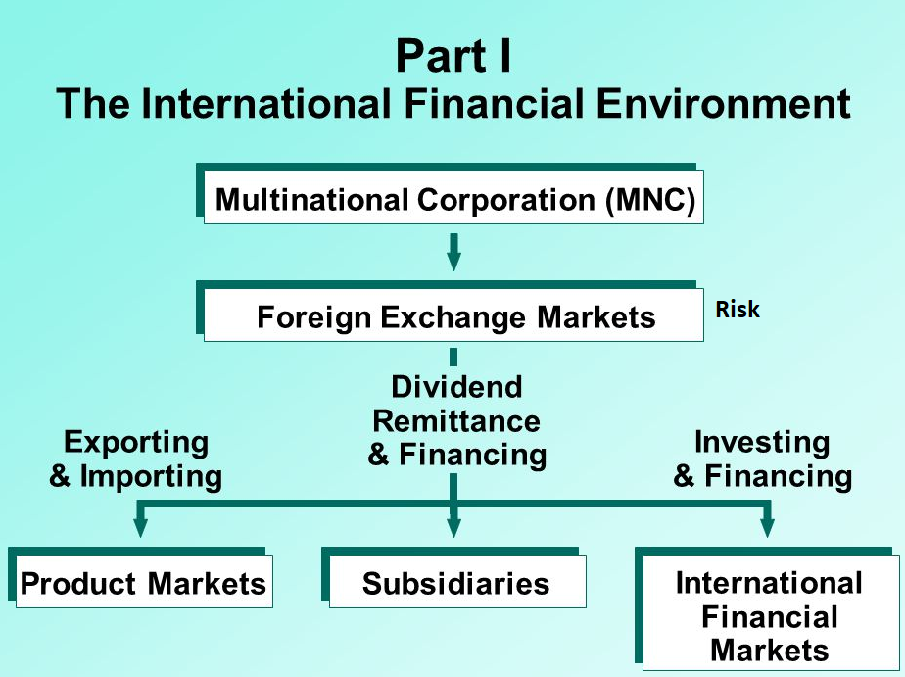

* **The main objective of international financial management is to maximize shareholder wealth.**
* This would require making **sound investment and financing decisions** that would result in **adding value to the firm**.
* If the shareholder wealth is maximized or in other words if share price is made to go up **hostile (aggresive) takeover becomes difficult and costly**. Also, it becomes easier for a company to **attract additional capital from the investors** if it cares for increasing shareholder wealth.
* Companies which create more value will have **more money to distribute to all stakeholders** not only shareholders-be they **employees, managers or other beneficiaries** in the society.
* It has been argued, and very rightly so, that maximizing shareholder wealth is not the best way but the only way to benefit all stakeholders.
* Traditionally financial management is separated into two basic functions. The first is concerned with acquisition of funds, also known **as financing decision.** This function involves generating funds from internal as well as external sources. The effort is to get funds at the lowest cost possible.
* The second, that is, investment decision is concerned with deployment of the acquired funds in a manner so as to maximize shareholder wealth. Other decisions relate to dividend payment, working capital and capital structure etc. In addition, risk management involves both **financing and investment decision**.
* A finance manager in an MNC faces many challenges that his counterpart in a domestic firm does not encounter. These challenges include **political risks** leading to expropriation or confiscation of assets, **exchange rate risk**, control on repatriation of **profits, different tax laws, multiple money markets and different interest rates** etc.
* MNCs and their financial managers have to be abreast with the changes taking place all the time and develop ways to take advantages of the changes while reducing risks that these changes create. They have operations in different countries. This gives them opportunity to access **segmented capital markets** to lower their overall cost of capital.
* They can **shift profits to lower the tax outflows**. They have ability to move people, money and material on a global basis to derive the maximum advantage out of these resources- They are able to practice the economic adage, “**do not put all your eggs in one basket**”. International diversification of markets and production facilities reduces their risk. Operating globally gives **MNCs continuous access to information on the latest process technologies and latest R&D activities** of their competitors. They are able to access world's capital markets and thus diversify their funding sources. International finance manager has to analyze and balance international risks and advantages.
* Some of the key challenges he must be prepared to face are listed hereunder:

• To understand the interrelationship between environmental changes and corporate response. For example, how will the credit conditions be impacted by stock market crash? How will defaults by some debtor countries affect funding ability in the international capital market?

• To understand the development and use of new instruments such as options, forwards futures and swaps for effective management.

• To develop ways to minimize risks through internal and external techniques.

• To take a balanced view of successes and failures, treating them as experiences to learn from. Decisions such as taking loan in a currency that has started appreciating fast, taking a fixed rate financing when rates have started going down will have an adverse impact and impel finance manager to contain the damage to the extent possible.

International financial management will involve the study of

a. exchange rate and currency markets,

b. theory and practice of estimating future exchange rate,

c. various risks such as political/ country risk, exchange rate risk and interest rate risk,

d. various risk management techniques,

e. cost of capital and capital

budgeting in international context,

f. working capital management,

g. balance of payment, and

h. international financial institutions etc.

2.3.2 Multinational corporations

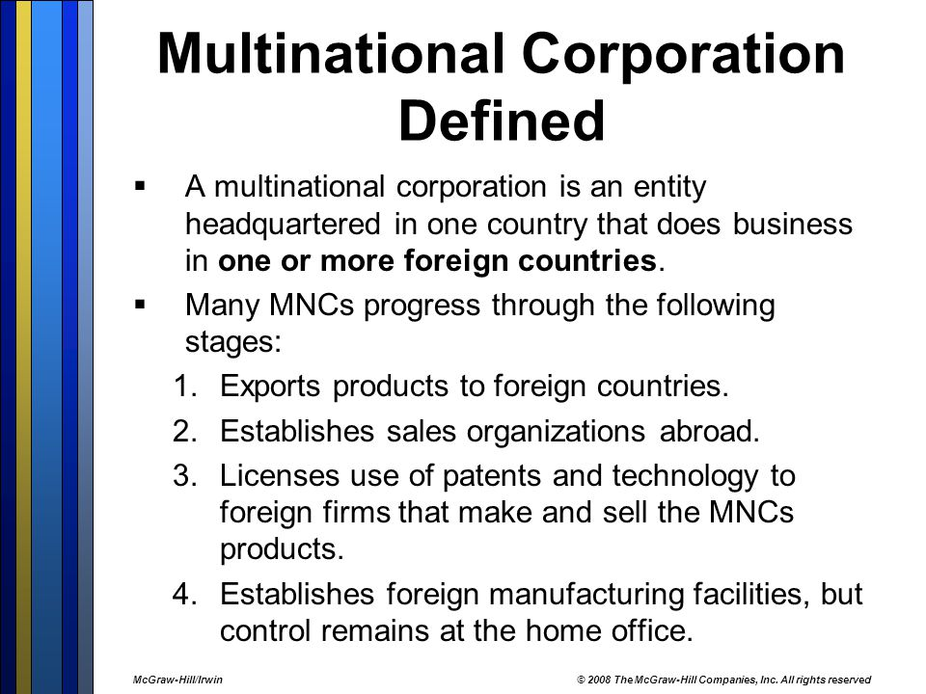

Multinational corporations (MNCs) are defined as firms that engage in **some form of international business**. Their managers conduct international financial management, which involves international **investing and financing** **decisions** that are intended to maximize the **value of the MNC**.

The goal of their managers is to **maximize the value of the firm**, which is similar to the goal of managers employed by domestic companies. Initially, firms may merely attempt to **export products to a particular country or import supplies from a foreign manufacturer**.

Over time, however, many of them recognize additional foreign opportunities and eventually establish **subsidiaries in foreign countries**. Dow Chemical, IBM, Nike, and many other firms have more than half of their assets in foreign countries.

Some businesses, such as ExxonMobil, Fortune Brands, and Colgate-Palmolive, commonly generate more than half of their sales in foreign countries. Even smaller U.S. firms commonly generate more than 20 percent of their sales in foreign markets, including Ferro (Ohio) and Medtronic (Minnesota). Seventy-five percent of U.S. firms that export have fewer than 100employees.

International financial management is important even to companies that have no **international business because these companies must recognize how their foreign competitors** will be affected by movements in **exchange rates, foreign interest rates, labor costs, and inflation.**

Such economic characteristics can affect the **foreign competitors’ costs of production and pricing policies**.

This chapter provides background on the goals, motives, and valuation of an MNC.

**GROWTH AND DEVELOPMENT OF MNC'S**

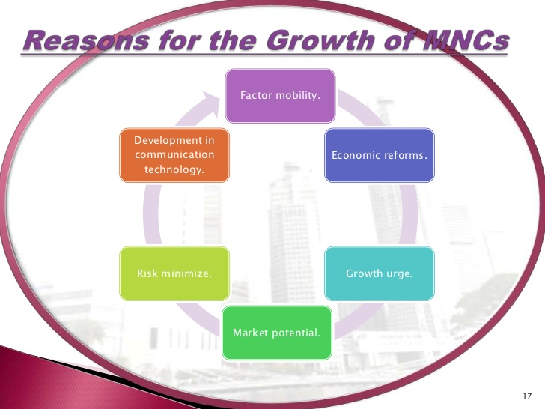

An MNC is a company engaged in **making and selling its products in more than one country**. It operates in other countries through **subsidiary companies or branches**. Unlike earlier days, the factors of production (capital, raw material, technology and labour) tend to move from **one place to another within a country as also from country to country** in search of higher returns.

Natural resources have their value but even more important are **new technologies that give rise to genetic engineering and miniaturization**. Capital as a resource is no longer monopoly (control) of a nation state bound by geographical borders; it moves around the world.

A typical MNC **raises capital in several countries** simultaneously or sequentially. **Technologies** may be **developed** in one country but **used** in **different countries**.

**Labour also, despite many restrictions**, is becoming increasingly global. People move easily from one country to another to acquire new skills to use them in a **third country**.

The ability of MNCs to use these globally available factors of production makes them competitive rather than the **resource endowments of the parent country.**

The existence of an MNC is based on the **international mobility of factors of production.** An **Indian parent company** may **raise finances in the US capital** market to use it to **acquire a company in Malaysia** and sell the products of this acquired company in Latin American countries. Part of the labour force employed in the Malaysian subsidiary may come from other South East Asian countries such as Indonesia, Philippines and Thailand etc.

In today's context, **development of design and other software can be done in far-off locations** and used in **other corner of the world** as these travel with the speed of light on information networks.

**Value addition** in products takes place at **different locations in different countries** before they are finally consumed.

Beginning in 1980s and accelerating from 1990s onwards, the world has witnessed some fundamental evolution on **technological, regulatory and economic policy fronts**.

Some of the elements of this evolution are:

(i) a large scale deregulation, cutting down the system of licenses and permits; (ii) substantial reduction in public sector enterprises and increase in privatisation;

(iii) increased development and use of information technology:

(iv) a large numbers of mergers, takeovers and buyouts of corporate entities to have better structure and control; and

(v) an increasing and more visible adoption of free-market policies in the developing countries etc.

This process has brought about competition in all sorts of activities be they manufacturing selling or providing services. The business organizations have been investing heavily in new technologic and developing new strategies in order to gain in productivity as well as expand their markets.

MNCs are the main entities to induce competition across the world. They do so by allocating resources globally in an optimal manner.

They make decision on the aspects such as **ownership, production, financing and marketing** with a single aim as to what is best for the corporation as a whole.

The emphasis is on group performance rather than the achievements of individual subsidiaries. As of now there are many MNCs with their headquarters in the USA or in Europe or in Japan. But gradually, MNCs of other countries are taking shape.

Some of the well known American MNCs are: Coca-cola, Colgate-Palmolive, Compaq. Dow Chemical and IBM etc. Coca-cola earns more than three-fourths of its revenues from outside the USA. As a matter of fact, earning more than half of their revenues outside the parent country is a norm for a large majority of MNCs. Yet, one can come across vast differences in the extent to which foreign operations are of importance to MNCs. For example. General Motors generates its revenues abroad in much greater proportions than its counterparts, Ford and Chrysler Internationalisation of certain industry groups or some companies is mind boggling.

For example, a film was made by a Hungarian-born producer, directed by a Dutch, starred an Austrian hero and a Canadian villain, shot in Mexico and distributed by a studio of Hollywood, which was owned by a Japanese. If we look at the evolution of the goals of MNCs, they can be seen evolving on the path of raw-material seekers, then market seekers and cost minimizes. The raw material seekers were the earliest ones.

They grew under the protection of various empires such as British. French and Dutch. The modern counterparts of those multinationals of colonial period are some of the big oil and mining companies.

Some examples of these 20th century MNCs are British Petroleum, Standard Oil. International Nickel etc. But more typical of today‘s MNCs are those that go abroad to seek larger markets. Several names can be cited of market seekers. Some are Unilever, IBM, MacDonald's and Coca-Cola etc. Most of the market seekers maintain vast manufacturing, marketing and distribution networks, spread over several countries. The third category, viz, cost minimizes, is fairly recent development.

The MNCs of this category invest in lower cost production sites such as China, Taiwan, Hongkong and India etc. But with time, such categorization is becoming blurred as also the direction of investment flows. Earlier, flows were from US to other countries, then came European and Japanese MNCs and now onwards, MNCs of other countries are also developing.

**GROWTH STRATEGIES FOLLOWED BY MNC'S**

Growth is a way of life. Almost all organizations plan to expand. This strategy is followed when an organization aims at higher growth by broadening its one or more of its business in terms of their respective customer groups, customers functions, and alternative technologies singly or jointly – in order to improve its overall performance. There are five types of expansion (Growth) strategies

**Expansion through concentration** It involves **joining resources in one or more of firms businesses** in terms of their respective customer needs, customer functions, or alternative technologies either singly or jointly, in such a manner that it results in expansions. A firm that is familiar with an industry would naturally like to invest more in known business rather than unknown business.

Concentration can be done through

**• Market Penetration:** It involves selling more products to the same market by focusing intensely on existing markets with its present products, increasing usage by existing customers and increasing market share and restructures a mature market by driving out competitors E.g.: Low pricing strategies

**• Market Development:** It involves selling the same products to new markets by attracting new users to its existing products. Market development can be geographic wise and demographic wise. E.g.: XEROX Company educated small business entrepreneurs to create new markets.

• **Product Development:** It involves selling new products to the same markets by introducing newer products in existing markets. E.g.: the tourism industry in India has not been able to attract new customers in significant numbers. New products such as selling India as a golfing or ayuerveda-based medical treatment destination are some of the product development efforts in the tourism industry to attract more tourists.

**Advantages of concentration strategies**

• Involves minimal organizational changes and is less threatening.

• Enables the firm to specialize by gaining the in-depth knowledge of the businesses.

• Enables the firm to develop competitive advantage.

• Decision-making can be made easily as there is a high level of productivity.

• Systems and processes within the firm become familiar to the people in the organization.

**Disadvantages of concentration strategies**

• It is dependent on one industry if there is any worse condition in the industry the firm will be affected.

• Factors such as product obsolescence, fickleness of market, emergence of newer technologies are threat to concentrated firm

• Mangers may not be able to sustain interest and find the work less challenging.

• It may lead to cash flow problems.

**Expansion through Integration**

It is done where the company attempts to widen the scope of its business definition in such a manner that it results in serving the same set of customers. The alternative technology of the business undergoes a change. It is combing activities related to the present activity of a firm. Such a combination may be done through value chain.

A value chain is a set of interrelated activity performed by an organization right from the procurement of basic raw materials down to the marketing of finished products to the ultimate customers.

E.g.: Several process based industry such as petro chemicals, steel, textiles of hydrocarbons have integrate firm A make or buy decision is then made when firms wish to negotiate with the suppliers or buyers.

The cost of making the items used in the manufacture of ones owns products are to be evaluated against the cost of procuring them from suppliers. If the cost of making is less that the cost of procurement then the firm moves up the value chain to make the item itself. Likewise if the cost of selling the finished products is lesser than the price paid to the sellers to do the same thing then the firm would go for direct selling. Among the integration strategies are of two type's vertical and horizontal integration. Vertical Integration: when an organization starts making new products that serve its own needs vertical integration takes place.

Vertical integration could be of two types **Back ward and forward integration.** **Backward integration means moving back to the source of raw materials while forward integration moves the organization nearer to the ultimate customer.**

Generally, when firms vertically integrate they do so in a complete manner that is they move backward or forward decisively resulting in a full integration but when a firm does not commit it fully it is possible to have partial vertical integration strategies too.

Two such partial vertical integration strategies are ‘taper’ integration and ‘quasi’ integration. Taper integration requires firms to make a part of their own requirements and to buy the rest from outsiders. Through quasi integration strategies firm purchase most of their requirements from other firms in which they have an ownership stake. Ancillary industrial units and outsourcing through sub contracting are adapted forms of quasi integration. Horizontal Integration: when an organization takes up the same type of products at the same level of production or marketing process, it is said to follow a strategy of horizontal integration. When a luggage company takes over its rival luggage company, it is horizontal integration. Horizontal integration strategy may be frequently adopted with a view to expand geographically by buying a competitors business, to increase the market share or to benefit from economies of scale.

**Expansion through Diversification** Diversification is a much used and much talked about set of strategies**. It involves a substantial change in the business definition – singly or jointly- in terms of customer groups or alternative technologies of one or more of a firm's businesses. .** There are two categories, concentric and conglomerate diversification. 2.______ a substantial change in the business definition – singly or jointly- in terms of customer groups or alternative technologies of one or more of a firm’s businesses.

**Concentric Diversification:** when an organization takes up an activity in such a manner that is related to the existing business definition of one or more of firms businesses, either in terms of customer groups, customer's functions or alternative technologies, it is called concentric diversification. Concentric diversification may be of three types:

1. **Marketing related concentric diversification:** when a similar type of product is offered with a help of unrelated technology for e.g., a company in the sewing machine business diversifies in to kitchen ware and household appliances, which are sold to house wives through a chain of retail stores.

2. **Technology- related concentric diversification:** when a new type of product or service is provided with the help of related technology, for e.g., a leasing firm offering hire- purchase services to institutional customers also starts consumer financing for the purchase of durable sot individual customers.

3**. Marketing- technology related concentric diversification:** when a similar type of product is provided with the help of related technology, for

e.g., a rain coat manufacturer makes other rubber based items, such as water proof shoes and rubber gloves sold through the same retail outlets

**Conglomerate Diversification:** when an organization adopts a strategy which requires taking of those activities which are unrelated to the existing businesses definition of one or more of its businesses either in terms of their respective customer groups, customer functions or alternative technologies. Example of Indian company which have adopted a part of growth and expansion through conglomerate diversification the classic examples is of ITC, a cigarette company diversifying into the hotel industry

**Expansion through Cooperation**

The term cooperation expresses the idea of simultaneous competition and cooperation among rival firms for mutual benefits. Cooperative strategies could be of the following types:

1. Mergers 2. Takeovers

3. Joint ventures 4. Strategic alliances Mergers Strategies: A merger is a combination of two or more organizations in which one acquires the assets and liabilities of the other in exchange for shares or cash or both the organization are dissolved and the assets and liabilities are combined and new stock is issued.

For the organization, which acquires another, it is an acquisition. For the organization, which is acquired, it is a merger. If both the organization dissolves their identity to create a new organization, it is consolidation. There are different types of mergers they are horizontal merger, vertical merger, concentric merger and conglomerate merger.

• **Horizontal Mergers:** it takes place when there is a combination of two or more organizations in the same business. E.g: A company making footwear combines with another footwear company, or a retailer of pharmaceutical combines with another retailer in the same businesses.

**• Vertical Mergers:** It takes place when there is a combination of two or more organizations, not necessarily in the same business, which create complementarities either in terms of supply of raw materials (input) or marketing of goods and services (outputs).

E.g: A footwear company combines with a leather tannery or with a chain shoe retail stores

**• Concentric Mergers:** It takes place when there is a combination of two or more organizations related to each other either in terms of customer functions, customer groups, or the alternative technologies used. E.g: A footwear company combining with a hosiery firm making socks or another specialty footwear company, or with a leather goods company making purse, hand bags and so on

• **Conglomerate Mergers:** It takes place when there is a combination of two or more organizations unrelated to each other, either in terms of customer functions, customer groups, or alternative technologies used.

E.g: A footwear company combining with a pharmaceutical firm. Takeover Strategies: Takeover or acquisition is a popular strategic alternative adopted by Indian companies. Acquisitions usually are based on the strong motivation of the buyer firm to acquire. Takeovers are frequently classified as hostile takeovers (which are against the wishes of the acquired firm) and friendly takeovers (by mutual consent)

• Friendly takeovers are where a takeover is not resisted or opposed, by the existing management or professionals. E.g: Tata Tea's takeover of Consolidated Coffee (a grower of coffee beans) and Asian Coffee (a processor) is an example of a friendly takeover.

• Hostile takeovers is where a takeover is resisted, or expected to be opposed, by the existing management or professionals.

Joint Venture Strategies: Joint ventures are a special case of consolidation where two or more companies from a temporary form a temporary partnership (also called a consortium) for a specified purpose. They occur when an independent firm is created by at least two other firms. Joint ventures may be useful to gain access to a new business mainly under these conditions

• When an activity is uneconomical for an organization to do alone.

• When the risk of business has to be shared.

• When the distinctive competence of two or more organization can be brought together.

• When the organization has to overcome the hurdles, such as import quotas, tariffs, nationalistic – political interests, and cultural roadblocks. Strategic alliances: They are partnership between firms whereby their resources, capabilities and core competencies are combined to pursue mutual interest to develop, manufacture, or distribute goods or services.

There are various advantages:

• Two or more firms unite to pursue a set of agreed upon goals but remain independent subsequent to the formation of the alliances. A pooling of resources, investment and risks occurs for mutual gain

• The partner firms contribute on a continuing basis in one or more key strategic areas, for example, technology, product and so forth.

• Strategic alliances offer a growth route in which merging one's entity, acquiring or being acquired, or creating a joint venture may not be required Global partners can help local firms by developing global quality consciousness, creating adherence to international quality standards, providing access to state of the art technology, gaining entry to world wide mass markets, and making funds available for expansions.

2.3.3 Foreign Direct Investment (FDI) in India

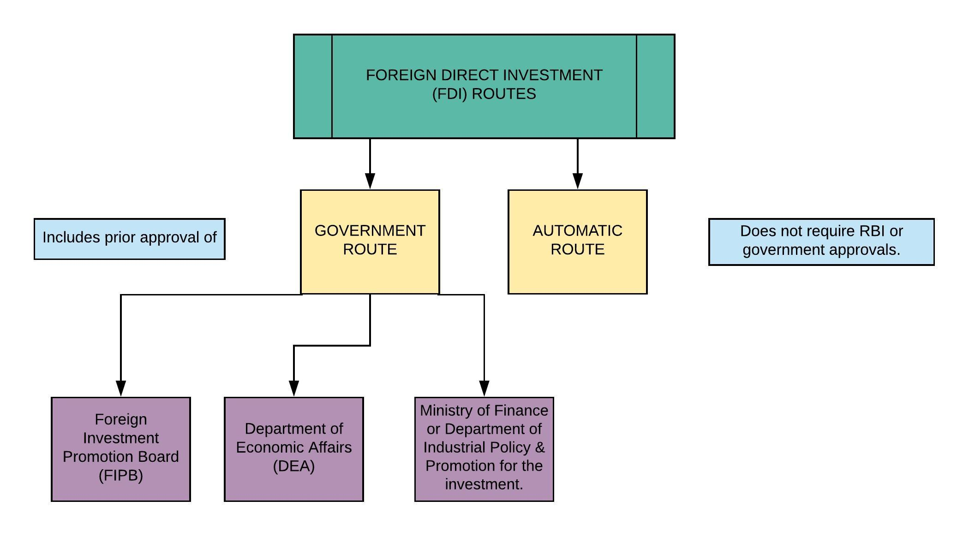

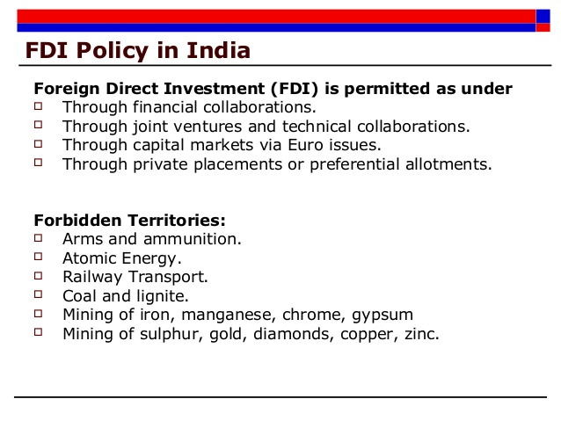

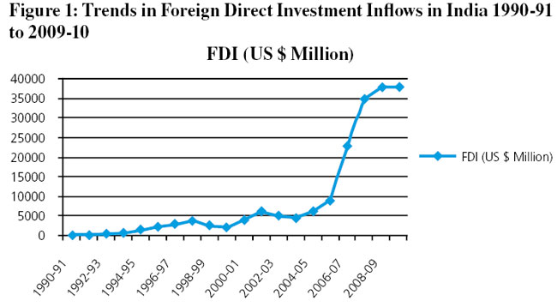

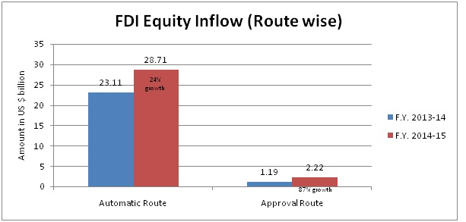

765 × 370Images may be subject to copyright. [Find out more](https://support.google.com/legal/answer/3463239?sa=X&ved=2ahUKEwitit_OwfbeAhXLv48KHexyCn8QlZ0DegQIARAB)

[Most Common Potential Determinants of FDI: Review](https://www.google.co.in/url?sa=i&source=images&cd=&cad=rja&uact=8&ved=2ahUKEwiV1v3VwfbeAhUIwI8KHbc-A7cQjhx6BAgBEAM&url=https%3A%2F%2Fresearchleap.com%2Fmost-common-potential-determinants-fdi-review-literature%2F&psig=AOvVaw3ralVZ2KKU0vKn8VDFpo4L&ust=1543474740885886)

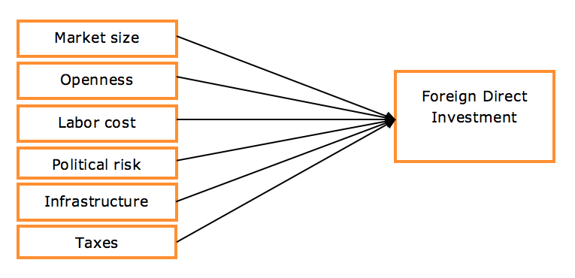

Foreign direct investments (FDI) are a major driving force behind the growth

of Indian financial markets. Post liberalisation in 1990s, the country is being viewed as a strategic destination by foreign majors to park their investments and benefit from the economic growth. 3. FDI stands for ______. India remains the world's third most attractive destination for investment by transnational corporations (TNCs) during 2013-15, stated a recent survey by UNCTAD. The country was ranked after china and the US in the survey based on responses of 159 companies. Moreover, this economic segment enjoys high attention from top officials of the Government, owing to its strategic importance. The Government keeps making efforts to provide impetus to FDI flows in the country and hence undertakes numerous reform initiatives. FDI norms were further liberalised after September 2012 in sectors like civil aviation, power exchanges and retail. The Ministry of Finance has also suggested modifications in FDI caps for various sectors, including tea, media, natural gas and petroleum.

• **India Inc witnessed an increase of 25 per cent** year-on-year (yo- y) to record US$ 2.32 billion of FDI in April 2013. Sectors that attracted highest levels of FDI include hotels and tourism sector (US$ 2.32 billion), followed by pharmaceuticals (US$ 987 million), services (US$ 238 million), chemicals (US$ 51 million) and construction sector (US$ 32 million). Singapore alone infused FDI flows worth US$ 1.29 billion in April 2013, followed by Mauritius, the Netherlands and the US with FDI inflows worth US$ 355 million, US$ 173 million Key Statistics and US$ 149 million respectively. FDI inflows aggregated at US$ 22.42 billion in 2012-13. .

• **India's foreign exchange (forex) reserves stood** at US$ 280.167 billion for the week ended July 5, 2013, according to data released by the central bank. The value of foreign currency assets (FCA) - the biggest component of the forex reserves – stood at US$ 252.103 billion, according to the weekly statistical supplement released by the Reserve Bank of India (RBI).

• **Private equity (PE) firms** upped their investments in India Inc by a hefty 42 per cent to US$ 5.4 billion through 197 deals during the first half of 2013; major deal being the US$ 1.2 billion-Bharti Airtel deal,

* **Meanwhile, Merger and acquisition (M&A)** activity in India was also quite intense in April-June 2013 period. The deal tally stood at US$ 10.9 billion across 130 transactions, according to global deal tracking firm Merger market.

**Important Developments** Foreign Investment Promotion Board (FIPB) has granted approvals to various FDI proposals recently. Telenor Mobile Communication AS, has been given a nod to invest Rs 1,000 crore (US$ 168.53 million) to raise its stake in Telewings to 74 per cent while Mahle Holding India Ltd has been allowed to bring Rs 280 crore (US$ 47.2 million) into the country. On the other hand UK-based Aveva Solutions Ltd's proposal for setting up a Limited Liability Partnership (LLP) for software development by investing Rs 8.39 crore (US$ 1.41 million) has been granted a green signal by the FIPB. Bangladeshi RabiulAlam also aims to set up a new company in India with 100 per cent FDI to manufacture engineering products by investing Rs 20.28 crore (US$ 3.42 million). This proposal has also got a nod from the FIPB. The aromatic basmati rice industry is attracting increasing investor interest in India. The Abu Dhabi-based Al Dahra International Investment LLC is planning to invest about Rs 112 crore (US$ 18.88 million) in Kohinoor Foods Ltd (KFL) through equity shares allotment on a preferential basis. Al Dahra's investment in Kohinoor Foods is second such instance of a West Asian firm investing in an Indian rice company. Recently, Hassad Foods, (part of the Qatar Investment Authority, the Sovereign Wealth Fund of Qatar) has announced that it would acquire a majority stake in the Delhi-based Bush Foods Overseas Pvt Ltd, a basmati rice and ready-to-eat products manufacturer. This trend is of immense significance as West Asia is the biggest market for basmati rice and India has a major market share in the region. German firm SEA Group is the world's fifth largest living space solution provider. It has debuted in India with an initial investment of Rs 14 crore (US$ 2.36 million), which could go up to Rs 40 crore (US$ 6.74 million) in two years. The company aims to undertake projects in association with big builders, mainly through the franchisee route and offer “creative, durable and high quality home interior solutions to end consumers and corporate clients”. While SEA Group has long experiences in German and other European markets, it has now teamed up with leading manufacturers in Europe like bauformatKüchen to bring high quality services to India. Meanwhile, US-based Customers Ban corp Inc (CUBI) has plans to infuse US$ 51 million in multiple securities of Religare Enterprises Ltd. Religare is currently aspiring for a banking licence to enter the banking industry. The investments will take place through a combination of primary and secondary market transactions.

**Policy Initiatives**

The Indian Government keeps making efforts to sustain global investors’ confidence in Indian markets. Prime Minister Manmohan Singh has recently extended his support to the finance ministry and industry department's plan to raise FDI ceiling in telecom to 100 per cent, besides allowing overseas flows into several sectors without prior government approval. The list of sectors where foreign majors would be allowed to invest through the automatic route includes oil and gas refining, courier and commodity and power exchanges. Meanwhile, the Central Government has approved 16 FDI proposals recently, in consultation with the FIPB. The proposals amounted to Rs.1646.875 crore (US$ 277.55 million).

**Future Outlook** Foreign investments fuel Indian financial markets in a big way.Experts believe that India has fared really well over the past few years. and the similar macroeconomic trends would continue in 2013. This would result in steady foreign flows that would enhance stock valuations, strengthen investment cycle, and sustain consumption growth (especially at low-income levels). Moreover, portfolio fund flows are anticipated to be higher in 2013 than those in 2012, on the back of Government reforms like passing bills that would escalate foreign investment limits in insurance, having a uniform goods and services tax, and reconciling subsidies. Following the decisions taken in September 2012, the Government is also expected to further relax the FDI regime in sectors such as telecom and defence. India is anticipated to need about US$ 1 trillion from 2012-13 to 2016-17 to fund infrastructure development such as ports, airports and highways to boost growth. A relaxed FDI framework would smoothen the process undoubtedly.

**FDI rules in multi-brand retail eased**

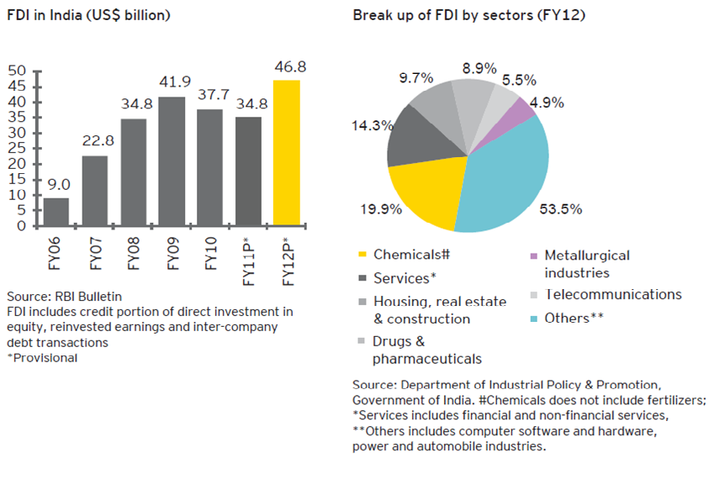NEW DELHI: In its latest bid to woo global chains such as Wal-Mart and Carrefour, the government on Thursday sweetened the deal for foreign investment in multi-brand retail stores besides liberalizing rules for overseas companies looking to invest in manufacturing defence goods or running telecom companies. Foreign retailers will now be allowed to open stores in cities that have a population of less than one million. Earlier, supermarkets could only come up in 53 cities. A relaxation was permitted only in case of states that did not have a single city with a population of one million. The move will allow stores to come up in cities such as Gurgaon and Aurangabad. The cabinet also approved a plan to tighten norms for ‘control’ of firms to ensure foreign players do not overwhelm any joint venture. The cabinet decision to open doors for FDI was an official endorsement of a decision taken at a meeting chaired by Prime Minister Manmohan Singh to ease the rules in nearly a dozen sectors. In most sectors, the simplification will allow companies to only inform the government after investment instead of having to get the proposal approved by the Foreign Investment Promotion Board. With no investor setting shop after the government allowed FDI in multibrand retail 10 months ago, the government has decided to water down some of the provisions which were seen as obstacles to investment. TOI was the first report on the changes on June 28, when commerce & industry minister Anand Sharma met retailers to get a feedback on the policy. Sharma told reporters that retailers can now source goods from medium, small and micro enterprises, where the investment cap will be $2 million (around Rs 12 crore), instead of the earlier ceiling of $1 million to comply with the requirement of sourcing at least 30% goods from small vendors. Further, sourcing can continue even after the $2 million investment cap is breached. "You can‘t penalize a small company for being competitive, Sharma reasoned. As a further relaxation in the rules, the government has said that retailers can buy from farmers’ and agriculture cooperatives, which will be counted in the sourcing requirement. The sourcing norms have to be met over a five-year period. To address another concern, the government has said that at least 50% of total FDI brought in the first tranche of $ 100 million will be invested in creating backend infrastructure within three years. "Subsequent investment in the backend infrastructure would be made by the retailer as needed, depending upon his business requirements, Sharma said. While Sharma ruled out the possibility of dilution of the policy by another political party, retailers were guarded in their response. "We are studying the government's recent revisions to the FDI policy and remain optimistic about the opportunity in front of us, a Wal- Mart India spokesperson said in a statement. But consultants appeared more upbeat. "These changes would address the concerns of the foreign investor who have till date tried to understand the nuances of the FDI policy related to multi brand retail, said Dev Raj Singh, executive director at consulting firm EY.

2.3.4GLOBAL DEPOSITARY RECEIPTS (GDRs)

**Global Depository Receipt** (GDR) is a certificate issued by an international bank to a company against purchasing some shares of the same company which are then traded on international stock exchange.

Simply, they are derivative equities which are traded in foreign markets, giving rights to shareholders for respective amount of local securities. In such case, shareholders are entitled to all dividends and capital gains. Thus, GDR allow investors in any country to purchase shares of company in any other country without losing the income or trading flexibility. GDR is also called as International Depository Receipt or Euro Depository Receipt.  
GDR is a financial instrument used by private markets to raise capital denominated in either U.S. dollars or euros. GDR facilitates trade of shares importantly in emerging markets.

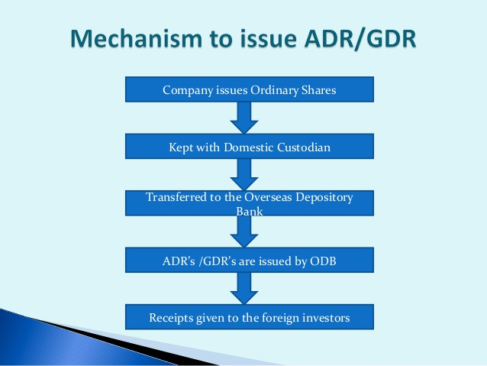

Univ. Notes.

GDR is a security issued abroad and is listed and traded on a foreign stock exchange. GDR holder can at any time convert it into shares represented by it. Till conversion, GDRs do not carry any voting right. Depository receipts facilitate cross border trading and settlement, minimise transaction cost and broaden the potential investor base. 4._______ is a security issued abroad and is listed and traded on a foreign stock exchange. The shares are issued by a company to an intermediary called the depository in whose name, the shares are registered. This depository subsequently issues the GDRs. The physical possession of equity shares is entrusted to another intermediary called the custodian who acts as an agent of depository .The advantage in GDR issue is that company does not assume any exchange risk. The dividend outflow from the company is in Rupees only but depository converts these rupee payments and pays the dividend in US dollar to the ultimate investors after deducting a withholding tax of 10 per cent on deposit. Once a GDR has been issued, it can be freely traded among international investors. GDR plays a crucial role in international corporate finance.

**GDR's are used to:**

I. raise debt or equity capital;

II. diversify shareholder base;

III. increase demand for securities;

IV. enhance global image; and

V. create dollar-securities.

The depository performs the following functions:

• Issuing depository receipts upon delivery of the underlying security to its custodian account and releasing the underlying security into the home market upon cancellation of DR.

• Processing DR transfers, maintaining records of registered holders, paying dividends and responding to shareholder enquiries.

• Holding. consultations with the issuer to promote its DR programme, reporting on the progress, supplying trading and shareholding information andproviding assistance in ensuring regulatory compliance.

**Cost of GDR issues Cost of issue of GDR comprises of following components**:

I. Brokerage.

II. Underwriter commission.

III. Management fee.

IV. Legal fee

V. Travel and road shows.

VI. Printing and stationery,

VII. Listing fee.

VIII. Stamp duty.

IX. Accounting fees. In a size of $ 50 million euro issue, cost would be around 4 to 6 per cent whereas in a issue of equivalent size in domestic market, the cost would be between 14-18 per cent.

**PROCEDURE FOR GDR**

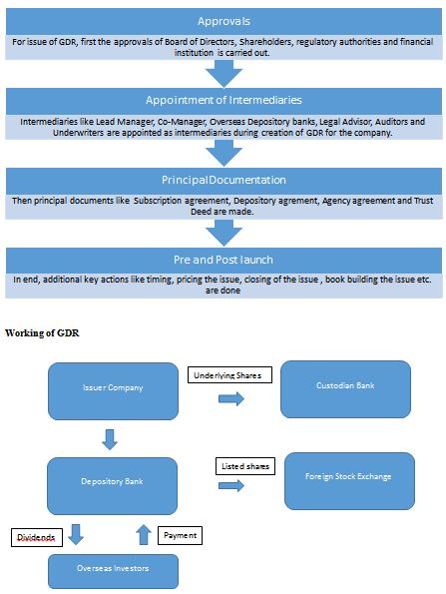

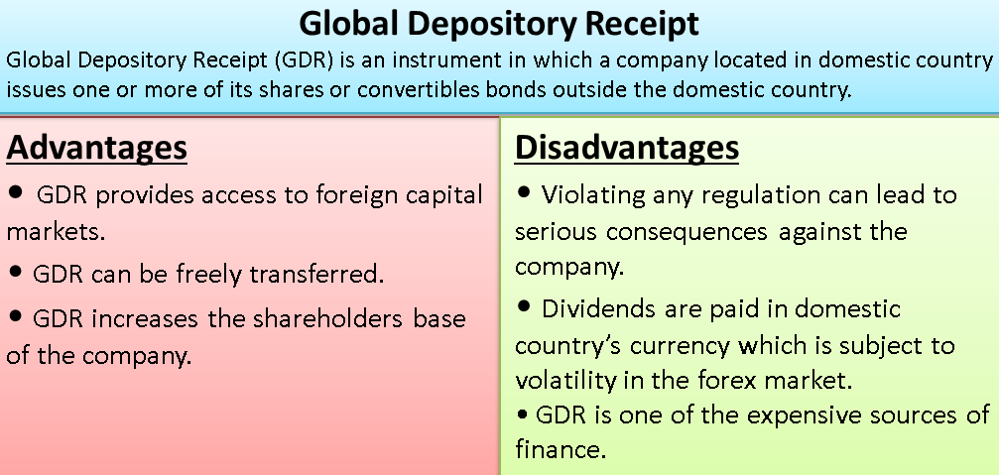

2.3.5 AMERICAN DEPOSITORY RECEIPTS (ADRs)

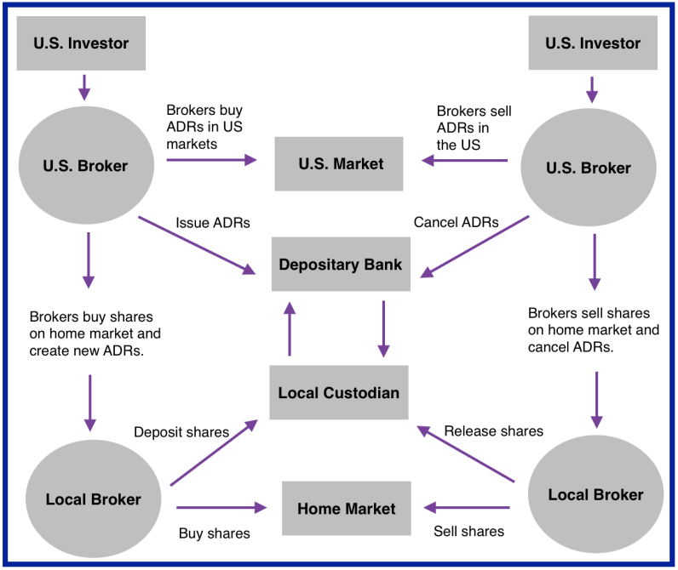

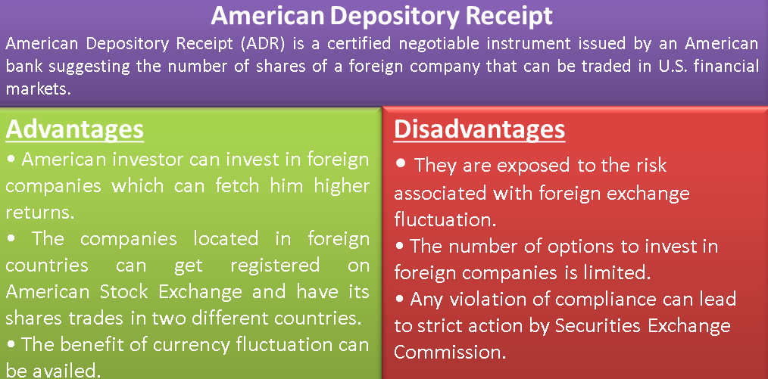

**Difference between ADRs & GDRs**

**Characteristics of an ADR**

**Meaning of GDR and ADR**

The primary difference between ADR and GDR is that ADR is a depository receipt that is issued by an American bank representing a specific number of shares of a non-US enterprise wishing to raise investment money in the US stock exchange.

On the other hand, the GDR receipt is a negotiable instrument that is issued by an international depository institution or bank which represents a foreign corporation that is offering its shares to the global market, except the United States stock market.

**Objective/Purpose of GDR and ADR**

The objective of the American Depository Receipt is to help foreign companies to acquire finances by the sale of shares to the United States citizens. Besides, it offers investors in the United States to invest in foreign countries.

The purpose of the Global Depository Receipt (GDR) is to help international companies to seek financing of their operations from investors in different countries around the world. Additionally, investors can invest in companies in different parts of the world.

**Trading Jurisdiction of GDR and ADR**

Using the American Depository Receipt (ADR), the companies have the authority to trade in the United States market, hence offering shares to the US citizens who may wish to invest in foreign companies and receive their dividends in dollars.

However, the holders of the Global Depository Receipt (GDR) can only possess buy shares of the companies trading in the international markets, mostly the European countries but the cannot purchase shares of the companies selling in the united states.

**Disclosure of Terms for GDR and ADR**

The disclosure of all the requirements required for trading activities under the American Depository Receipts (ADR) is onerous. The Securities Exchange Commission (SEC) has placed onerous terms so that investors do not lose their cash.

This is not the same for the Global Depository Receipts (GDR) where the terms of trade and requirements are less onerous. This means that there is less control of the trading platform and investors are likely to lose their investments.

**Listing of Stock of GDR and ADR**

The American Depository Receipts (ADR) are listed on the American stock exchange. Therefore, an individual who wants to purchase ADR can access them from the New York Securities Exchange (NYSE) and the National Association of Security Dealers Automated Quotations (NASDAQ).

Global Depository Receipts (GDR) can only be acquired in other parts of the world expect the United States. Therefore, a person wishing to purchase GDR can buy them on the London Stock Exchange and the Luxembourg Stock Exchange among other security markets across Europe.

**Restrictions in GDR and ADR**

The American Depository Receipt (ADR) can only be negotiated and issued in the United States of America. Besides, all the transactions are quoted in dollars and investors are paid their dividends in US dollars.

The Global Deposit Receipt (GDR) is negotiated and issued in all parts of the world, except the United States of America. Moreover, the currency of transaction may change concerning the origin of the company offering its shares.

**Difference Between GDR vs. ADR: Comparison Table**

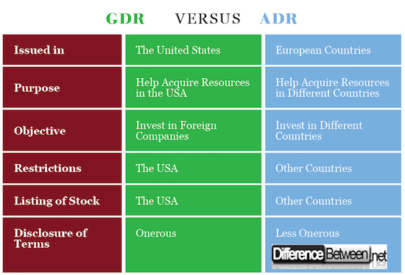

Level 1 This is the most basic type of ADR where foreign companies either don‘t qualify or don't wish to have their ADR listed on an exchange. Levell ADRs are found on the OTC market and are an easy and inexpensive way to gauge interest for its securities in North America. Levell ADRs also have the loosest requirements from the SEC.

Level 2: This type of ADR is listed on an exchange or quoted on NASDAQ. These ADRs have slightly more rigorous requirements from the SEC but they also get higher visibility and trading volume.

Level 3: The most prestigious of the three, this is when an issuer floats a public offering of ADRs on a U.S. exchange. Level 3 ADRs are able to raise capital at low cost and gain substantial visibility in the U.S. financial markets.

**The advantages of ADRs are twofold.**

For individuals, ADRs are an easy and cost effective way to buy shares in a foreign company. They save considerable money by reducing administration costs and avoiding foreign taxes on each transaction.

Foreign entities like ADRs because they get more U.S. exposure and allow them to tap into the wealthy North American equity markets. In return, the foreign company must provide detailed financial information to the sponsoring bank. A significant portion of public offering by non-US companies (and we're most concerned with Indian companies) in the US is in the form of ADRs, or American Depository Receipts (also called American Depository Shares or ADS).

ADRs are negotiable receipts issued to investors by an authorised depository, normally a US bank or depository, in lieu of shares of the foreign company which are actually held by the depository. ADRs can be listed and traded in a US-based stock exchange and help the Indian company to be known in the highly liquid US stock exchanges. ADRs also help the US-based and other foreign investors to have the twin benefits of having share holding in a high growth Indian company and the convenience of trading in a highly liquid and well-known stock market.

**Procedure of ADR issue (Below is General DR)**

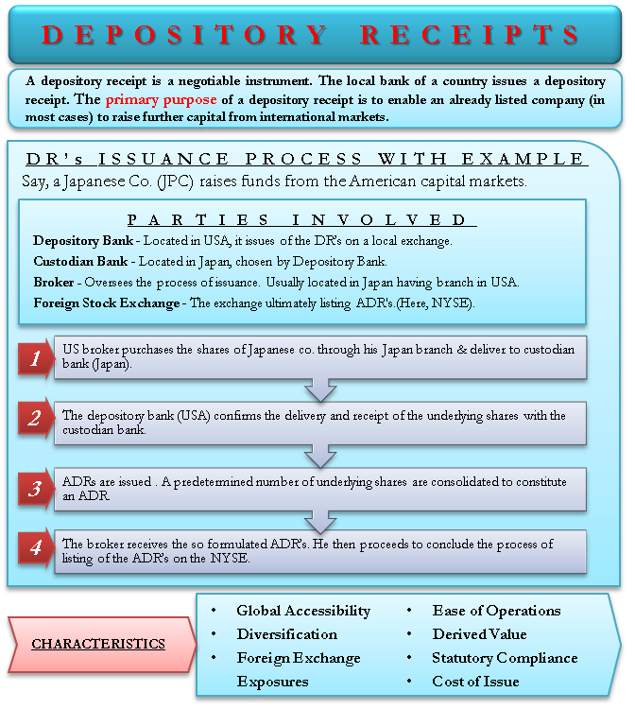

The International Bond Market consists of the Euro bond market, the Foreign Bond market and those Domestic Bond market (such as the US, Japanese and French markets), in which global bond investors participate actively. The most international of these markets is the Euro bond market. The Euro bond market raises over US$ 200 billion per annum in new capital for corporations, financial institutions and governments. Domestic Bonds are usually fixedinterest, fixed-maturity claims with ranging maturities from 1-30 years. They are issued by domestic residents, in the domestic currency, and largely sold to domestic residents. Foreign Bonds are issued within the domestic market of the currency of denomination, but they are issued by non-resident borrowers. For example, a bond issued within the UK by a non resident issuer such as the Asian Development Bank is a Foreign Bond. Euro bonds are usually issued in the market for the borrower by a syndicate of banks from different countries and placed in countries other than the one in whose currency the bond is denominated. If the German firm issued a bond in French francs in England, Switzerland, the issue is a Euro bond. 6. The euro will be created as the currency of the European monetary union on ________.

**CREATION OF EURO**

The euro will be created as the currency of the European monetary union on 1 January 1999. This will have substantial implications for the international monetary system; for the currency composition of portfolios; for exchange rates, and hence monetary policies; and for economic efficiency and welfare. The key determinant of the extent and speed of internationalization of the euro will be transaction costs in foreign exchange and securities markets. There has been extensive discussion of the potential international role of the euro, most without any underlying analytical framework. We propose a new analytical basis for this discussion and offer specific estimates of the consequences, using new data.

**BENEFITS OF THE EURO**

The euro will help for economic stability in Estonia, ensuring low inflation and low interest rates in the long term that are a pre-condition for durable economic prosperity. The single currency will bring stable prices for citizens and more opportunities for businesses. Moreover, being part of the single currency and the euro area will also create greater trade opportunities in the global economy and attract foreign investment.

**PRICE STABILITY**

By adopting the single currency, Estonia will join an economic and monetary union of stable prices and low interest rates. The euro area has a proven track record of maintaining price stability. Before the euro, it was not rare for many Member States to have inflation rates well above 10% or even 20%. Beyond the impact of the recent global crisis, the political determination to join the euro area has been an important element of domestic policy in Estonia contributing to much reduced inflation levels. As euro area inflation has remained only just above 2% in the last 10 years, the EMU's culture of economic stability should help maintain stable price expectations in Estonia.

**Job creation**

The benefits brought by the euro will help sustain robust economic growth and create more jobs for Estonian citizens. Membership of economic and monetary union means a stable economy that supports business, boosts trade and inspires the confidence of foreign investors. Combined, these advantages will help support the recovery of the Estonian economy and foster a swifter decline in its currently high unemployment. In the euro area, job creation has been significantly higher since the introduction of the euro; nearly 16 million jobs have been created since the launch of the single currency in 1999 compared to only 3 million in the 8 preceding years.

**LOW INTEREST RATES** Estonia will benefit from the low interest rates in the long term that are a pre-condition for durable economic prosperity. This will bring very practical benefits, allowing Estonian citizens and businesses to borrow with more confidence and security. Membership of the euro area will help shield Estonia against economic turbulence and significant interest rate increases.

**REDUCED COSTS FOR TRAVELLERS**

With the disappearance of transaction costs, Estonian citizens will be able to travel in the euro area for leisure or business at lower expense. They will not only be relieved of the hassle of changing money at borders but can expect to make considerable savings. While abroad, and thanks to the euro, citizens can now send money home to friends and family at a fraction of the cost. Before the euro, the average bank fee to transfer the equivalent of €100 to another country was €24. Now the average cost has been reduced to just €2.50.

**LOWER COSTS FOR BUSINESSES**

The euro saves money for Estonian enterprises and supports a dynamic business environment. Following the introduction of the euro and the disappearance of transaction costs, businesses in the European Union have been relieved of an estimated€20-25 billion in costs. In Estonia, a considerable amount of transaction costs will also be saved after the changeover to the euro. This will allow Estonian companies to invest more in job creation and to become more competitive.

**INCREASED TRADE**

The euro will facilitate trade by eliminating transaction costs and exchange rate risks, making Estonia a more attractive trading partner for existing euro area members. It is estimated that the euro has already increased trade within the euro area by 4-10% since its launch. For Estonia, this represents a significant advantage due to the high openness of its economy as, in 2008; external trade represented over 180% of GDP, while around 35% of Estonian exports were to euro area members.

**A STRONG AND ATTRACTIVE INTERNATIONAL CURRENCY**

With the euro, Estonia will have a currency of global rank. The role of the euro in international trade, the global bond market and as an official reserve currency has increased substantially and will continue to grow in importance. On some measures, the euro has even overtaken the US dollar in the international bond market, representing almost 49% of outstanding bonds as opposed to 35% for the dollar at the end of 2007. Euro cash is also increasingly used outside the euro area, with 10-20% of the total value of euro banknotes in circulation currently held outside the euro area, while for the US dollar the value reaches an estimated 60%. The attractiveness of the euro as a world currency means that tourists can increasingly travel all over the world with euro in their pockets while businesses are increasingly able to trade in euro beyond the borders of the euro area. The value of euro coins and bills in circulation recently overtook that of US dollars, with 1,075.8 billion US dollar worth of euro coins and bills in circulation versus 816.9 billion US dollar coins and bills in March 2008.

**EMERGENCY OF EURO CURRENCY MARKETS**

Within national borders, the sole use of one currency is usually imposed by government fiat. Only in exceptional circumstances, such as very rapid inflation, is a national currency replaced in one or more of its functions by other currencies or commodities. In the international economy, demand factors play a much more important role in the determination of which currencies are used. The view that public (state) use of a currency precedes and dictates private use (Goodhart, 1996) is not valid in the international domain. Since there is no supranational authority that can impose the use of a single currency, these issues are decided in the market place, by the behaviour of private and public agents of all countries. But here the market may not function well: because of economies of scale and externalities in the use of currencies, as well as considerable uncertainty and asymmetric information, there is no guarantee that the world will end up with the best monetary system, let alone a single international currency. There is, however, an important lesson from the models of international money: history will matter. Once an exchange structure is established, it will persist unless the system experiences a shock large enough to shift it from one equilibrium to another (Krugman 1980, Rey 1997a).

**Euro Deposits**

The term `euro' denotes that the issue is listed on a European Stock Exchange. A euro issue is an issue where the securities are issued in a currency different from the currency of the country of issue and the securities are sold in international market to individual and institutional investors. Euro securities are negotiable and transferable securities distributed by a syndicate of market intermediaries and underwriters, By an euro issue, a company is able to raise funds at a cheaper rate, Euro bond is an international bond issued to investors from throughout the world. These are issued as unsecured obligations. Indian Companies issue Euro Deposits foreign currency convertible bonds (FCCB) which are equity linked debt instruments, convertible into equity at a specified later date. They carry a fixed rate of interest which is lower than the rate on any other similar nonconvertible debt instrument. FCCBs are freely transferable, tradable and the issuer has no control over the transfer. The table: 1 highlights EURO issues in the recent past. Table

1:

Euro

Issues

by

Indian

Companies

(Rs.Crore)

Year

Amount

Raised

No. of Euro

Issues

(1) (2) (3)

1992-93 10232 2

1993-94 7.897.82 27

1994-95 6.743.23 31

1995-96 1,296.69 5

1996-97 5.59427 16

1997-98 4.009.46 7

1998-99 1.147.78 3

1999.00 3.48721 6

2000-01 4197.07 13

2001-02 234.50 5

Total 37.417.35 115

It suggests the quantum jump in the

amount raised over ten years.

It will be interesting to note that the

foreign investment in the country has

also increased significantly during

this period.

**2.3.7 Internatioanl Fiancial Markets**

The share of US dollar bonds in the international bond market has fallen substantially since the early 1980s: from 62% of the stock of bonds outstanding in 1985 to only 38% at end-1996 (of a total stock amounting to $3,200 billion), with a corresponding sharp rise in the share of yen-denominated bonds to 16% (BIS 1997, p.11). According to McCauley and White (1997, p. 11), the euro money market is likely to prove a very liquid market from its inception (see also European Commission 1997a). Even a ‘narrow’ monetary union (essentially France and Germany) would have a market in derivative transactions larger than that for the yen and a larger market than the dollar for futures on longerdated government securities (Prati and Schinasi, 1997).

**The Official Sector**

We have focused so far on privatesector behaviour, because we believe that financial market use of an international currency takes the lead, that use as a vehicle currency is the main determinant of use by the monetary authorities as an intervention currency (Kenen 1995, p.110), and that this in turn determines use as a reserve currency (Krugman 1984, p.273). But reserveholding and currency pegging by governments deserve some attention. Pegging too, we believe, either follows the establishment of a currency as an international currency or is dictated by international politics (e.g. the CFA franc zone, the prospective incorporation of at least some of the ‘Associated Countries’ of Central and Eastern Europe in the Exchange Rate Mechanism Mark. The share of the US dollar in official reserves, although declining, is overwhelmingly higher than the share of any other single currency.3 From 76.1% of total official currency reserves in 1973, the dollar fell to 63.3% in 1994. The share of major European currencies shows a steady increase, from 14.3% in 1973 to 21.9% in 1994 (the share of the DM has risen from 7.1% to 15.5%). The Japanese yen rose from almost zero in 1973 to 8.5% of the total in 1994.

2.3.8 Offshore bank

An offshore bank is a bank located outside the country of residence of the depositor, typically in a low tax jurisdiction (or tax haven) that provides financial and legal advantages. These advantages typically include:

• greater privacy (see also bank secrecy, a principle born with the 1934 Swiss Banking Act)

• low or no taxation (i.e. tax havens)

• easy access to deposits (at least in terms of regulation)

• protection against local, political, or financial instability While the term originates from the Channel Islands being “offshore” from the United Kingdom, and most offshore banks are located in island nations to this day, the term is used figuratively to refer to such banks regardless of location, including Swiss banks and those of other landlocked nations such as Luxembourg and Andorra. Offshore banking has often been associated with the underground economy and organized crime, via tax evasion and money laundering; however, legally, offshore banking does not prevent assets from being subject to personal income tax on interest. Except for certain persons who meet fairly complex requirements, the personal income tax of many countries makes no distinction between interest earned in local banks and those earned abroad. Persons subject to US income tax, for example, are required to declare on penalty of perjury, any offshore bank accounts—which may or may not be numbered bank accounts—they may have. Although offshore banks may decide not to report income to other tax authorities, and have no legal obligation to do so as they are protected by bank secrecy, this does not make the non-declaration of the income by the tax-payer or the evasion of the tax on that income legal. Following September 11, 2001, there have been many calls for more regulation on international finance, in particular concerning offshore banks, tax havens, and clearing houses such as Clear stream, based in Luxembourg, being possible crossroads for major illegal money flows. Defenders of offshore banking have criticised these attempts at regulation. They claim the process is prompted not by security and financial concerns but by the desire of domestic banks and tax agencies to access the money held in offshore accounts. They cite the fact that offshore banking offers a competitive threat to the banking and taxation systems in developed countries, suggesting that Organisation for Economic Co-operation and Development (OECD) countries are trying to stamp out competition.

2.3.9 Tax Havens

A country that offers foreign individuals and businesses little or no tax liability in a politically and economically stable environment. Tax havens also provide little or no financial information to foreign tax authorities. Individuals and businesses that do not reside a tax haven can take advantage of these countries‘ tax regimes to avoid paying taxes in their home countries. Tax havens do not require that an individual reside in or a business operate out of that country in order to benefit from its tax policies. Andorra, the Bahamas, Belize, Bermuda, the British Virgin Islands, the Cayman Islands, the Channel Islands, the Cook Islands, Hong Kong, the Isle of Man, Mauritius, Lichtenstein, Monaco, Panama, Switzerland and St. Kitts and Nevis are all considered tax havens. However, pressure from foreign governments that want to collect all the tax revenue they believe they are entitled to has caused some tax haven countries to sign tax information exchange agreements (TIEAs) and mutual legal assistance treaties (MLAT) that provide foreign governments with formerly secret information about investors’ offshore accounts.

2.4 Summary

International financial markets have a great importance in the present world due to an increased number of cross border transaction.The International money market helps the MNCs in raising short –term funds in their respective currency. The International credit market helps the government and the MNCs in raising medium –term funds by means of credit or issuing notes.The International bond market facilitates international business by providing long –term loans to MNCs.

2.5 Keywords used in the lesson International financial management, FDI, GDR, ADR, Euro bonds and Tax- Havens

2.6 Further reading

1. International Financial Management – ArunVerma, Ph.D&Kogent Learning Solutions Inc. DreamTech Press, New Delhi, 2012 Edition. 2. Hodgetts : International Management. Tata McGraw Hill, New Delhi. 3. Koonts and Whelrich : Management: The Global Perspective , Tata McGraw Hill, New Delhi. 4. Nagandhi, Anant.R: International Management ,Prentice Hall of India Ltd., New Delhi. 5. Thakur, Manab,Gene E. Burton, and B.N. Srivastava: International Management: Concepts and Cases, Tata McGraw Hill, New Delhi. 6. Christoppher Bartlett and SumantraGhoshal, Transnational Management: Text and Cases, Tata McGraw Hill, New Delhi

**2.7 Answer to check your progress questions**

1. Share holder 2. Diversification 3. Foreign Direct Investments 4. Global Depository receipts 5. 1927 6. 1st January,1999

**2.8 Model questions**

1. Discuss the concept and features of International Financial Management (IFM).

2. Examine the growth and development of MNC.

3. Bring out the different types of diversification in International trade.

4. Discuss the importance of FDI in India.

5. Write short note on

a. GDR b. ADR c. Euro-bonds d. Off-shore banks e. Tax havens

**UNIT-III**

**Foreign Exchange Exposure and Management**

3.1. Introduction 3.2 Unit Objective 3.3 Unit structure 3.3.1 Transaction Exposure 3.3.2 Translation Exposure 3.3.3Economic Exposure 3.3.4Hedging 3.3.5Managing currency risk with derivatives 3.3.6 Futures and Options 3.3.7 Currency increased significantly during this period.

3.3.1 Transaction Exposure

The risk, faced by companies involved in international trade, those currency exchange rates will change after the companies have already entered into financial obligations. Such exposure to fluctuating exchange rates can lead to major losses for firms. Often, when a company identifies such exposure to changing exchange rates, it will choose to implement a hedging strategy, using forward rates to lock in an exchange rate and thus eliminate the exposure to the risk.

**MANAGEMENT OF TRANSACTION EXPOSURE**

**Transaction exposure** - Currency risk when a firm faces contractual CFs fixed (invoiced) in another currency - receive or pay a fixed amount of foreign currency in the future, i.e. any receivable (AR), or payable (AP) in a foreign currency. Source of currency risk from transaction exposure for MNC could be either: a) export/import activities, or b) borrowing/lending activities - anytime future CFs (to be paid or received) is fixed in a foreign currency.

1. _________ when a firm faces contractual CFs fixed (invoiced) in another currency - receive or pay a fixed amount of foreign currency in the future, i.e. any receivable (AR), or payable (AP) in a foreign currency.

Example: U.S. firm sells its product to a German client for €1m, payable in 3 months, now faces transaction exposure since the CFs are fixed in Euros, and the future value of the Euro is uncertain, meaning that the dollars received are uncertain. Worried about?? Example: U.S. firm borrows in U.K. pounds, owes £1m in one year, faces transaction exposure since the CFs are fixed in a foreign currency. Worried about?? Unlike many forms of currency risk (economic exposure), currency risk in the form of transaction exposure is always easily identifiable and quantifiable, because the exact amount of the CFs, payable or receivable, are known and certain, and the timing of the CFs is known. An example of economic exposure is the effect of future currency fluctuations on sales revenue for Merck or GM, which is more uncertain and harder to quantify. Transaction exposure always involves known and certain CFs, so the risk exposure is well defined. Financial contracts (derivatives) and operational techniques can be used to deal with transaction exposure. Boeing Corporation (NYSE: BA, DJIA stock), a U.S. MNC, exports a 747 to British Airways, invoice is for £10m, payable in one year. Int. rates and FX rates are: U.S. interest rate (one year) = 6.10% U.K. interest rate (one year) = 9.00% S = $1.50/£ F1 = $1.46/£ (one-year forward rate)

**3.3.2 Translation Exposure**

The risk of loss that might arise due to changes in value of the stock, revenue, assets or liabilities of a business due to foreign exchange rate movements. A business has translation exposure when

The risk of loss that might arise due to changes in value of the stock, revenue, assets or liabilities of a business due to foreign exchange rate movements,called as ________. some of its stock, revenue, assets or liabilities are denominated in a foreign currency and need to be translated back to its base currency for accounting purposes.

3.3.3 MANAGEMENT OF ECONOMIC EXPOSURE

It covers another type of foreign exchange risk and discusses risk management techniques for

**Economic Exposure** - the extent to which the value of the firm will affected by exchange rate uncertainty. We discuss how to measure economic exposure, what determines it, and how to manage and hedge economic exposure. Changes in ex-rates can affect a firm's:

a) Balance Sheet and

b) Income Statement.

3. The extent to which the value of the firm will affected by exchange rate uncertainty, called as _________.

Even a purely domestic firm, using only domestic parts (no imports), selling only in the domestic market (no exports), all AR and AP in local currency, etc., will be affected by changes in ex-rates. How? Point: As business becomes increasingly global, exchange rate changes (volatility) become more important, even for a purely domestic firm operating in a global market. Firms have to pay more attention to exchange rate risk, and devise hedging strategies to manage and control currency risk. How the 37% depreciation of the Mexican peso affected U.S. and Mexican companies in 1995. Example: Dollar depreciated against the Yen in the late 1980s. Affected the competitive position of Japanese auto makers selling vehicles in U.S., since they would have to raise dollar prices to maintain profitability in Yen. If the market is extremely competitive, that may not be possible without losing market share. Whether Toyota loses market share or not, profits probably fall when Yen appreciates. On the other hand, the fall in the dollar helped importcompeting U.S. car makers, made them more competitive. Dollar appreciated during the early 1980s, hit an all-time high in 1985, helping Japanese auto makers, hurt import-competing U.S. companies. Japanese car makers could lower the dollar price of cars sold in the U.S., and still receive the same amount of Yen as before. The dollar has depreciated by about 11% against most major currencies (14% against the Euro) over the last year, which has had a major effect on many U.S. and foreign businesses. These examples illustrate the effects of changes in ex-rates on a firm's operating CFs, by affecting its competitive position, increasing or decreasing SLS revenues, COGS, input prices, operating profits, market share, share price, market value, etc.,

i.e. **Economic Exposure (vs. Transaction Exposure).** Currency fluctuations also affect a firm‘s Balance Sheet by changing the value of the firm's assets and liabilities, another type of Economic Exposure. Example: Laker Airways, a British airline, pioneered the mass-market, high-volume, no-frills, low-fare air travel in the early 1980s. It borrowed heavily in dollars to buy airplanes (making fixed payments in $), but received more than half its revenue in British pounds. The $ appreciated in the early 1980s, peaked in 1985, and the pound was depreciating, dramatically increasing the debt burden of Laker Airways, forcing it into bankruptcy. Illustrates how serious currency risk can be. Economic Exposure depends on the unique characteristics of an industry and the individual characteristics of an individual firm. One way to measure **Economic Exposure for an industry is to calculate the Forex Beta, Market Beta is** calculated as:

Ri= a + β (Rm) + ei, where Ri is the monthly return on an industry portfolio of Fortune 500 companies, and Rm is the monthly market return (S&P500).

Market betas range from .310 (Mining and crude oil) to 1.613 (transportation equipment). All betas are significant at the 1% level. Forex Beta is calculated as: Ri = a+ β (S) + ei, where S is the monthly dollar exchange rate index (FX/$). A positive (negative) Forex Beta means that when the dollar appreciates (depreciates), the stock returns for that industry go up(down). Of the 25 industries, 10 had a statistically significant (10% level or higher, noted by *) Forex Betas: 6 pos. Betas and 4 neg. betas. Positive Forex Betas: Electronics, Furniture, Metals, Motor Vehicles and Parts, Textiles, Transportation. Dollar appreciates, foreign currencies depreciate, stock prices go up. What might they have in common??? Negative Forex Betas: Petroleum Refining, Pharmaceuticals, Science/ Photo Equipment, Tobacco. Dollar depreciates, foreign currency appreciates, stock prices go up. What might they have in common???

**HOW TO MEASURE ECONOMIC EXPOSURE**

Potential currency risk (unpredictable, random changes in ex-rates) is not the same as Currency Exposure, which is the firm's **actual exposure** to currency risk. If a company is hedged properly it might be insulated from currency risk and face no actual currency exposure. Example:U.S. company enters into an agreement to either receive $s (for exports) or pay $ (for imports), essentially transferring the currency exposure to the foreign company. Example: You own foreign real estate, office building in U.K., in which case you may not face currency exposure. Reason: assume that changes in the pound are directly related to British inflation and British asset values for real assets. Over a given period, Pound depreciates by 4%/year against the dollar, UK inflation is 4% higher than U.S., British real estate appreciates at the rate of inflation (4%), insulating and protecting you against the pound falling. Dollar value of the asset is insensitive to ex-rate changes. You have no actual currency exposure, even though currency risk still exists. Example: Fixed income security, British bond, with payments in BPs. Your investment CFs are now fixed in BPs, making them highly sensitive to changes in the value of the Pound. The dollar value of your income and asset value will fluctuate, and you now have unprotected currency exposure. For a firm, Currency Exposure is measured by the sensitivity of the firm's:

a) Balance Sheet, and b) Operating CFs to random changes in the ex-rate.

**ASSET EXPOSURE MEASUREMENT (THIS SECTION MAY BE SKIPPED)**

Example: Assume a U.S. company or investor has a U.K. asset that fluctuates in local currency under three scenarios. If we can quantify the possible changes in ex-rates, the value of the asset in pounds and the value of the asset in dollars, we can calculate the exact Exposure Coefficient (beta) that will then determine the exact foreign currency amount that should be hedged, to minimize (or eliminate) currency exposure (risk). Formula: P = a + β (S) + e, P* is the local currency price in BPs, S is the $/£ exchange rate, and P is dollar price of the foreign asset measure by: P = S x P*. See p. 226. Three possible outcomes for S (spot rate) with equal (1/3) probability: $1.40/£, $1.50/£ and $1.60/£ for Case 1, Case 2 and Case 3. Each case makes a different assumption about the relationship between changes in the £, changed in P* and changes in the dollar value of the British asset.

**Case 2 -** Like the real estate case from before. If the pound depreciates (appreciates) by 6%, the pound value of the asset goes up (down) by 6%, resulting in a dollar value of $1400 in each outcome. In this case, Beta (exposure coefficient) = 0, meaning that there is no currency exposure, a perfectly hedged position.

**Case 3 -** Like owning a British bond, you get P* = £1000 in every state of the world, regardless of what happens to S. In that case, your Beta (exposure coefficient) = £1000, indicating that your exposure to currency risk is in the amount of £1000, and that represents the amount of foreign currency that you should hedge.

Exposure Coefficient = exact amount of foreign exchange to hedge to either eliminate or minimize currency exposure. In Case 2, you would hedge 0 and in Case 3 you would hedge £1000. Case 1 - Similar to Case 3, except that now the dollar price of the British asset changes by MORE than the change in the pound. Starting with the middle case where S = $1.50 and P = $1500, when S goes down to $1.40 (approx. -7%), P goes down by -9.3%. When S = $1.60, pound goes up by about 7%, P goes up by 14%. In Case 3, when the pound fell (rose) by 7%, P fell (rose) by exactly 7%. Exposure Coefficient (Beta) is £1700, meaning that the optimal hedge is that amount. However, since P does not change 1-for-1 with S, there is no way to completely eliminate currency exposure. Assume that one year F = $1.50, and you hedge exactly £1700, and that the future spot rate is going to be either $1.4, $1.5 or $1.6 with equal probabilities. You sell £1700 forward at F = $1.50, so your profits/ loss from the hedge will be either: 1700 (1.50 - 1.60) = -$170 (pound appreciates) 1700 (1.50 - 1.50) = 0 1700 (1.50 - 1.40) = +$170 (pound depreciates) See page 227, Exhibit 9.4. Under this optimal hedge, the dollar price of your British asset in one year will be either $1542, 1500 or $1542, with equal probability (expected value = $1528, with a variance of 392). If you hedged some other amount, e.g. £1500 or £1900 instead of 1700, the expected value would the same ($1528), but the variance would be 658, which is > 392. Under Case 3 (fixed income), you can construct a perfect hedge since the CFs are certain, and the dollar value of the asset moves in a predictable and certain way with the changes in the ex-rate. You will receive $1500 in cash no matter what happens to the exchange rate. Point: When the CFs are uncertain and/or when the dollar value of the foreign asset does not change in value in proportion to changes in the exchange rate, even the optimal hedge does NOT completely eliminate currency exposure. Example: Think of trying to hedge currency exposure when owning a foreign stock, versus owning a foreign bond over a 5-year holding period.

3.3.4 Methods of Hedging

**OPERATIONAL HEDGING**

1. **Selecting Low-Cost Production Sites.** When domestic currency is strong (foreign currenciesweak), a domestic firm selling (exporting) products overseas will be a competitive disadvantage, e.g., U.S. manufacturers/exporters in the mid-1980s (strong dollar), Japan in the late 80s and 90s (strong Yen). Toyota shifting production to U.S. because the strong Yen (weak dollar) weakened their competitive position. Subaru, Isuzu, Mazda, Honda, Nissan, Toyota, BMW, and Mercedes have all shifted production to U.S. and Mexico (VW). U.S. has shifted production to Mexico in auto industry and other industries. Nissan has plants in U.S., Japan and Mexico, giving it flexibility to shift production in response to changes in exrates. Example: Yen appreciated to the dollar in 1990s, dollar appreciated to the peso. Nissan shifted production to U.S. and Mexico to serve the U.S. market.

Possible disadvantage: If there are significant economies of scale in manufacturing, spreading production over three smaller sites may not achieve the same cost efficiencies as one large factory.

1. **Flexible Sourcing Policy.** Even if all production is domestic, the firm can take advantage of changes in ex-rates if it has flexibility in sourcing. Example: When U.S. dollar is strong and foreign currencies depreciate, firm can take advantage by sourcing to those countries with weak currencies. Examples:U.S. and Japanese companies buying from Mexico, Thailand, Indonesia, Brazil, etc. Flexible sourcing includes foreign labor as well as foreign parts and raw materials. Hire low-cost foreign workers instead of high-cost domestic workers.
   1. Example:Japan Airlines hires foreign crews to stay competitive when the Yen is strong instead of domestic crews.
2. **Diversification of the Market.** Diversify by: a) selling the same product in more than one country, and b) selling several different product lines in more than one foreign market. As long as ex-rates don‘t move together perfectly against the dollar, and as long as ex-rates don't affect each product line the same, the diversification will mitigate operating exposure to currency risk.
   1. Example: GE diversifies by selling electric motors in Germany and Mexico (peso may depreciate when euro appreciates, SLS go down in _______ and up in _____), and gas generators in Thailand and Brazil.
3. **R&D Efforts and Product Differentiation.** 
   1. R&D can lead to increased production efficiency/productivity, which can make the firm more profitable and less exposed to operating exposure. Also, if the firm can developed highly specialized, differentiated products, e.g. leading to a patent, the demand for the firm's products will be more inelastic, less sensitive to ex-rate risk.
   2. Example: If a firm produces a homogenous, standardized commodity like steel, or wheat, or oil, demand will be very elastic - lots of substitutes. If a firm produces a specialized, differentiated product like a pharmaceutical product that no one else produces, the demand will be relatively inelastic, less sensitive to currency risk. Harley-Davidsons, Steinway pianos, Volvo, etc. all have unique product identities and niche markets.
4. **FINANCIAL HEDGING**

**Currency futures, swaps, options, forward contracts can be used to stabilize operating CFs.** Or firm can borrow or lend in a foreign currency. Financial hedging may be a more cost-effective strategy than operational hedging for many firms since it doesn't involve major redeployment of resources like building factories in other countries.

Example: U.S. manufacturer exports textile machinery to Europe, and also issues debt in Germany (in Euros). What if dollar strengthens? _____________________ DollarWeakens? ____________________________

**Mini-Case: Merck,** page 237. U.S. pharmaceutical MNC operates in 100 countries, and 40% of Merck's assets and 50% of its SLS are overseas. Merck faces currency mismatch because sales are in foreign currencies, and costs are mostly in dollars (R&D in U.S.). Merck profits are sensitive to currency changes: Profits ($) = Retail Prices (£, €, ¥) - Costs ($). What are they worried about? Merck considered shifting production overseas, redeploying resources to minimize currency risk (operational hedging), but decided it was impractical and not cost-effective. Therefore, it decided to use financial hedging: currency futures, options, forward contracts, etc. Process of strategic planning:

1. Forecast CFs and future ex-rates for 5 years to determine the exposure.

2. Merck determined that its currency mismatch (SLS in foreign currency, COGS in $) and currency volatility exposed the company to significant ex-rate risk. To remain competitive and justify continuing to spend lots of money on R&D, it decided to use financial hedging to control and manage risk. What was Merck worried about?

3. Considered options and futures. Decided on buying put options as a way to buy insurance (premium cost) against €/£/¥ falling, but it would still be able to profit if the dollar continued to depreciate against major currencies. See diagram on board.

Merck decided to: 1. use long term options rather than short term 2. only use a partial hedge and selfinsure the rest. **Forward Hedge**. Most direct and popular way to hedge currency risk is a **currency forward contract**, sell the £10m forward at $1.46/£ for a guaranteed receipt of $14.6m (£10m x $1.46/£), regardless of what happens to the spot rate. See Exhibits 8.2 and 8.3 on p. 195: If £ depreciates to $1.40 (what Boeing is worried about), they only receive $14m for the order (selling £10m at the spot rate), but the profit on the forward contract is $0.60m to make up the difference and Boeing nets $14.6m. If £ appreciates to $1.50, Boeing will receive $15m for the order, but will lose $0.4m on the forward contract, for a net of $14.6m. No matter what happens to S, Boeing will net $14.6m with a currency forward hedge, and will lock in ex-rate of $1.46/£.

**Currency Futures contract** could also be considered, and would essentially have the same outcome as a forward contract.

**Money Market Hedge.** Another strategy for Boeing: Borrow for 1 year in the U.K. in BPs @ 9%, with a £10m payoff, convert BPs to USDs at the spot rate, invest in the US @ 6.10%, and use the £10m receivable from British Airwaysin one year to pay off the BP loan in U.K. and keep the USDs from the payoff in the U.S. money market.

**Steps:**

1. Borrow in UK: £10m / 1.09 = £9,174,312 today for one year @ 9%, pay back £10m in one year 2. Convert the pounds into dollars today @S=$1.50/BP, for $13,761,468 (£9,174,312 x $1.50/£) 3. Invest $13,761,468 in the U.S. @ 6.1%

4. Collect £10m in one year from British Airways in UK and pay off the loan in U.K.(pay back £10m)

5. Receive the dollar proceeds of the investment in U.S. of $14,600,918 ($13,761,468 x 1.061)

If IRP is holding, the payoff for a forward contract and money market hedge are the same. IF IRP is not holding, then either the forward contract or the money market hedge may dominate the other. These options, being considered by many MNCs in competitive financial markets, would help to eliminate deviations from IRP. (Assumes that there is a single interest rate in both countries for borrowing and lending.)

**For a payable:** MNC would borrow USDs in the US, convert to BPs, invest in the UK money market for one year, and use the BP proceeds from the money market to pay the invoice in BPs in one year, and pay back the loan in the U.S. with dollars

**Options Market Hedge.**Possible disadvantage of a complete hedge with forward, futures contracts, money market hedge? Eliminates ALL currency risk, even any favorable exchange rate changes that can increase profits by raising revenues in the home currency when the foreign currency appreciates for AR, or lowering costs in home currency when the dollar appreciates for AP. Optimal amount of risk is not zero! Example: If the spot rate goes to$1.60/£, Boeing would get $16m instead of $14.6m, and gain $1.4m in additional dollar revenues. In other words, hedging would COST the firm $1.4m on an ex post (after the fact) basis. Boeing might regret hedging when the pound appreciates, to its advantage. Currency Options provide a possible solution by limiting the downside risk (£ depreciating) while preserving some of the upside risk potential (£ appreciating), in this case by buying a BP put option. Suppose that BP put options are selling for 2¢, or $0.02/ BP, with an exercise (strike) price of $1.46/BP, and 1 year expiration. Boeing buys £10m worth of put options for $200,000 (£10m x $0.02/£), giving it the right to sell £10m @ $1.46/£ for $14,600,000. BP Put Option Payoff Diagram: Option premium is due now, so considering the time value of money, the future dollar cost (one year) of the put options @ 6.1% is $200,000 (1.061) = $212,200 ($200,000 + $12,200 in foregone U.S. interest by tying up $200,000 for a year and losing the interest income). Suppose S = $1.30/£ in one year. Boeing exercises the option and receives $14.6m in gross proceeds for the £10m as follows: a. Spot: £10m x $1.30/£ = $13m (Converting £10m AR in BP to USD @ S = $1.30/£) b. ($1.46 / £ − $1.30/£) × £10m = $1.6m Gross Profit on Options Contract TOTAL $14.6m Gross Dollars Proceeds c. Options Cost (inc. opp. cost) ($212,200) NET PROCEEDS $14,387,800÷ £10m =Effective Ex-rate: $1.4387/£ If the BP does depreciate significantly (what BA is worried about), this establishes the minimum dollar receipt possible (vs. $13m without option in this case), and sets a floor for the £10m receivable. The put premium is like buying an insurance policy now for $200,000 that will guarantee that Boeing will get a MIN of $14,387,800 in one year, and maybe more if ____________. Suppose S = $1.40/£ in one year. Boeing exercises the option and receives $14.6m in gross proceeds for the £10m as follows: a. £10m x $1.40/£ = $14m (Converting £10m AR in BP to USD @ S = $1.40/£) b. ($1.46 / £ − $1.30/£) × £10m = $1.6m Gross Profit on Options Contract TOTAL $14.6m Gross Dollars Proceeds c. Options Cost (inc. opp. cost) ($212,200) NET PROCEEDS $14,387,800 ÷ £10m =Effective Ex-rate: $1.4387/£ S = $1.50/£ in one year. Now Boeing does not exercise the option, £ has appreciated in Boeing's favor. a. £10m x $1.50/£ = $15m (Converting £10m AR in BP to USD @ S = $1.50/£) b. Options Cost (inc. opp. cost) ($212,200) NET PROCEEDS $14,787,800÷ £10m =Effective Ex-rate: $1.4787/£ S = $1.60/£ in one year. Boeing does not exercise the option (it expires). a. £10m x $1.60/£ = $16m (Converting £10m AR in BP to USD @ S = $1.60/£) b. Options Cost (inc. opp. cost) ($212,200) NET PROCEEDS $15,787,800÷ £10m =Ex-rate: $1.5787/£ Break-even S* between put option and forward contract is $1.48/£. If S > $1.48, put option is better alterative, if S < $1.48 then forward hedge is slightly better by $212,200, the cost of the put option (assumes no cost for a forward contract). Put option allows Boeing to significantly limit the downside risk (£ falling), but preserve the upside potential (£ appreciating). Guarantee:Minimum proceeds of $14,387,800, and minimum exrate of $1.4387/£, with chance of $16m or more. Another advantage of put option vs. forward contract: Forward Contracts are only available at one forward rate for a given maturity, vs. put options - available at several exercise prices. For example, Boeing could buy another put option with a Ex-P higher than $1.46, (e.g., $1.48/£) and increase the minimum net dollar proceeds. Problem? See Exhibit 7.7 on p. 175 for quotes for Euro and Yen put options – note that there are 7 different puts for euro and 10 for Yen, at various exercise prices and premiums. For example, current currency puts and calls on the Philadelphia Stock Exchange (PHLX):

**December 2006 Put Options for BP (£31,250)PHLX(Spot rate was $1.9125/£ in November 2006)**

Ex-P Premium(¢/£) Contract Cost Breakeven (Ex-P + Premium) $1.92/£ 2.44¢ $762.50 $1.8956/£ $1.91 1.84 $575.00 $1.8916 $1.90 1.25 $390.625 $1.8875 $1.89 0.79 $246.875 $1.8821 $1.88 0.49 $153.125 $1.8751 $1.87 0.31 $96.875 $1.8679 $1.86 0.21 $65.625 $1.8579 $1.85 0.14 $43.75 $1.8486 $1.84 0.12 $37.50 $1.8388

Ex-P Premium(¢/£) Contract Cost Breakeven (Ex-P + Premium) $1.88/£ 2.33¢ $728.125 $1.9033/£ $1.89 1.65 $515.625 $1.9065 $1.90 1.10 $343.75 $1.9110 $1.91 0.70 $218.75 $1.9170 $1.92 0.46 $143.75 $1.9246 $1.93 0.31 $96.875 $1.9331 $1.94 0.22 $68.75 $1.9422 $1.95 0.14 $43.75 $1.9514 $1.96 0.12 $37.50 $1.9612

**December 2006 Call Options for BP (£31,250) PHLX**

See Exhibit 8.7, p. 200 for summary of 3 strategies for hedging currency risk of a receivable: Forward Contract, Money Market, Put Options.

**New Example: Hedging Foreign Currency Payables**

Boeing imports a jet-engine from Rolls Royce (RR) in UK, for £5m payable in one year. See ex-rates and interest rates on p. 200. Note: IRP is NOT holding (BP is expected to depreciate by _______, implying an effective dollar return of ____________ in UK vs. 6% in US).

Boeing is worried about? _____

Contines,…

**Cross-Hedging Currency Risk**

**Cross-Hedging Currency Risk** is possible when forward contracts are not available for minor currencies like Korean won, Thai baht, Brazilian real, Mexican peso, etc. Markets are too thin for those currencies, or nonexistent, or inefficient because of currency controls or regulations. Strategy: Use a currency futures or forward contract for a major currency to hedge currency risk for a highly correlated minor currency.

**Example:** Use a Yen contract to cross-hedge Korean won currency risk (AR in won for U.S. MNC), assuming that the Yen/Won correlation is high. Another type of cross-hedging is commodity-currency hedging, e.g. using oil or silvers futures contracts to hedge Mexican peso, copper futures to hedge Peruvian currency, gold for S. African rand, wool for Australian dollar, cocoa for Nigerian currency, coffee for Colombian peso, cotton for Indian rupee, or soybean or coffee futures to hedge Brazilian real. Works when a commodity futures prices move closely with an ex-rate.

**Example** : Brazil exports coffee to U.S. and produces 25% of world market, correlation between world coffee price in dollars and the Brazilian currency (real) should be high. Suppose there is a real shock, an increase in demand for coffee. What happens to the Brazilian currency? ___________ What happens to futures price of coffee in US? __________________ Suppose there is a nominal shock, overall price inflation in the U.S., and the dollar price of coffee in the US goes_______ in the spot and futures market, and the dollar goes _______ and the real goes _______ in the currency markets. Therefore there should be a _____ correlation between coffee prices on NYBOT.

**Hedging Examples:** a. Suppose GM buys transmissions from a company in Brazil and has a 90-day payable (A/P) for 1m reals. It would be worried about the dollar ____ and the real ____, so it would take a _____ position on 3-month coffee futures. (Assume there are no currency futures contracts for reals.) b. Suppose GM sells engines to a company in Brazil and has a 90-day receivable (A/R) for 1m reals. It would be worried about the real _______ and would take a _______ position on 3-month coffee futures.